**REPUBLIC OF KENYA** **COUNTY GOVERNMENT OF NYAMIRA**



**HEALTH SECTOR PLAN**

**(2023-2033)**



# VISION

A healthy and productive county with equitable access to quality health care.

# MISSION

To provide quality health services for socio-economic development of the people of Nyamira County

# Forward

The Constitution of Kenya 2010, the Kenya Vision 2030 and its Medium Term Plans, provide the foundation for the preparation of the First Sectoral Plans for Nyamira County. This Sectoral Plan, will be used to inform resource distribution, a tool of resource mobilization in the face of limited and competing priorities for the betterment of the lives of the people of Nyamira County. The Kenya Vision 2030 is the country’s development blueprint covering the period 2008 to 2030. It aims to transform Kenya into a newly industrializing, middle-income country providing a high quality of life to all its citizens by the year 2030. The County’s vision of embracing urbanization for accelerated socio- economic growth is in tandem with this overall national vision. The Sectoral Plans identify a number of flagship projects to be implemented across the country for all sectors. The County Government has identified county-specific flagship projects and Programmes that will be implemented at county level and work with the National Government and Key Stakeholders to ensure these projects are implemented in a responsible, transparent and cost-effective manner. The preparation of this Sectoral Plan is based on the County Governments Act, 2012 section 109 which mandates every county to prepare Sectoral Plans. The Sectoral Plan is a ten-year blue print that highlights the socio-economic challenges faced by the County, strategies for resources mobilization and programme interventions aimed at realizing our socioeconomic goals and desired impact. The preparation of the Sectoral plan was done through a participatory process that involved various stakeholders. The sectoral plans will provide a structured roadmap for planning, budgeting, implementation, monitoring, evaluation and reporting for programmes and projects within the sector over the ten-year planning period

## Dr.Ombati Mokua

## CECM

## Department of Health Services

# Acknowledgement

The 2023-2033 edition of the Health Sector Plan was prepared in accordance with section 109 of the County Government Act, 2012 and is the Second version since the inception of the County Government of Nyamira I would like to acknowledge the departments in the Sector for their various contribution without which this document would not be a success. All the department directorates in the Sector were invited to contribute in the preparation of the Sector plan. This information was analyzed by the team led by CECM Dr. Ombati Mokua. Acknowledgement is made to the Sector Working Group members who spent significant time and effort putting together the document; CCO Medical Services Mr. Andrew Ongere and CCO Primary Health Care Mr. Moenga Momanyi, Directors and coordinators Dr.Geoffrey Nyambuti, Mr.David Osumo, Ms. Rosemary Otiende and Mr.Kimani. Special acknowledgement to the Budgeting and Economic Planning team led by CCO Dr. Azenath Maobe, Director Economic Planning Mr. Paul Onyango and the Economic Planning Officer and Secretariat of the Sector Working Group Mrs. Novah Mokua for coordinating the process of preparing this Plan. Special thank you to the national government team; Martin Ogoti from KNBS, Rose Wakhuloba from National Population Council and the team from the National Treasury for providing technical backstopping in the preparation of this document. Finally, I am indebted to express my sincere gratitude to the entire staff of the Sub sectors for their dedication and commitment during the entire exercise.

**Mr. Andrew Ongere Mr. Moenga Momanyi**

**CCO CCO**

**Medical Services Primary Health Services**

Table of Contents

VISION 2

MISSION 2

Forward 3

Acknowledgement 4

List of Abbreviations and Acronyms 8

List of Tables 8

List of Maps and Figures 9

Executive Summary 11

CHAPTER ONE 12

INTRODUCTION 12

OVERVIEW AND BACKGROUND OF THE SECTOR 12

1.0 Introduction 13

1.1 Overview of the County 13

1.2 Background of the sector 15

1.3 Rationale for the County Sectoral Plan 16

1.4 Approach/methodology in the preparation of the sector plan 16

CHAPTER TWO 17

PERFORMANCE REVIEW OF THE PREVIOUS CIDP PERIOD 17

2.0 Introduction 18

2.1 Analysis of the County Revenue Sources 18

2.2 County Budget Expenditure Analysis 20

2.3 Sector Programmes Performance Review 20

2.4 Achievements 20

2.5 Challenges 21

2.6 Emerging issues 21

2.7 Lessons Learnt 21

2.8 Development Issues 21

CHAPTER THREE 26

SPATIAL PLAN FRAMEWORK 26

3.0 INTRODUCTION 27

3.1 SPATIAL DEVELOPMENT FRAMEWORK 27

3.2 STATUS OF COUNTY PHYSICAL AND LAND USE PLANNING STATUS 27

3.3 COUNTY RESOURCE POTENTIAL GROWTH AREAS. 28

3.3.1 Physiographic Characteristics 28

3.3.2 Population and Demography 39

3.3 Land and Land Use 42

3.3.1 Opportunities 43

3.3.2: Challenges 45

3.4 Environment and Natural Resources: 45

3.4.1 Opportunities: 46

3.4.1 Opportunities 48

3.4.2 Challenges 50

3. 5 Transport, Infrastructure and Services 51

3.5.1 Opportunities 51

3.6 ICT 54

3.6.1 Opportunities 54

3.6.2 Challenges 54

3.7 Energy 54

3.7.1 Opportunities 54

3.8 Water and Sanitation 57

3.8.1 Opportunities 57

3.8.2 Challenges 59

3.9 Education 60

3.10 Health 64

CHAPTER 4 67

DEVELOPMENT PRIORITIES, STRATEGIES AND PROGRAMMES 67

4.0 Introduction 68

4.1 Development Priorities and Strategies 68

4.2 Sector Programmes and Flagship Projects 70

4.2.1 Sector Programmes 70

4.2.2 Flagship Projects 85

4.3 CIDP Linkages with National Development Agenda, Regional and International 86

Development Frameworks 86

4.4 Cross-Sectoral Linkages 88

CHAPTER FIVE 90

SECTOR IMPLEMENTATION FRAMEWORK 90

5.1. Overview 91

5.2. Institutional Framework 91

5.3 Resource Mobilization and Management Framework 93

5.3.1 Resource Requirements by Sector 93

Source: Sectors 93

5.3.2: Revenue Projections 94

5.3.3 Estimated Resource Gap 96

5.3.4 Resource Mobilization and Management Strategies 96

5.4 Asset Management 96

5.5 Risk Management 96

CHAPTER SIX 98

MONITORING, EVALUATION AND LEARNING 98

6.1 Overview 99

6.2 County Monitoring and Evaluation Structure 99

6.3 M&E Capacity 99

6.4 M&E Outcome Indicators 99

6.5 Data Collection, Analysis and Reporting 100

6.6 Dissemination, Feedback Mechanism, Citizen Engagement and Learning 100

6.7 Evaluation Plan 100

# List of Abbreviations and Acronyms

SDGs Sustainable Development Goals

CIDP County Integrated Development Plan

CEC County Executive Committee

CCO County Chief Officer

MOH Ministry of Health

THSUC Transformation of Health services universal care

FP Family Planning

ICU Intensive Care Unit

HIV Human Immunodeficiency Virus

SARs Severe Acute Respiratory Syndrome

FIF Facility Improvement Fund

NCDs Non Communicable Diseases

GBVRC Gender Based Violence Rescue Centre

NCRH Nyamira County Referral Hospital

NHIF National Health Insurance Fund

OPD Out Patient Department

EMMS Essential Medicines and Medical Supplies

MIS Management Information System

STI Sexually Transmitted Infections

CHVs Community Health Volunteers

M&E Monitoring and Evaluation

APR Annual Progress Report

CGN County Government of Nyamira

AIDs Acquired ImmunoDeficiency Syndrome

UN United Nations

EAC East Africa Community

FGM Female Genital Mutilation

NEMA National Environment and Management Authority

COK Constitution of Kenya

GOK Government of Kenya

# List of Tables

**Table 1 Analysis of County Revenue Sources** 19

**Table 2 Sector Expenditure Analysis** 21

**Table 3 Sector Development issues** 23

**Table 4 Sector Priorities and Strategies** 70

**Table 5 Sector Programmes** 72

**Table 6 Flagship Projects** 86

**Table 7 Linkage with Kenya Vision 2030, other plans and international obligations** 88

**Table 8 Cross-sectoral impacts** 90

**Table 9 Stakeholders** 93

**Table 10 Summary of Sector Financial Resource Requirements** 94

**Table 11 Revenue Projections** 95

**Table 12 Resource Gaps** 97

**Table 13 Risk, Implication, Level and Mitigation Measures** 97

**Table 14 Outcome Indicator Reporting** 100

**Table 15 Evaluation Plan** 102

### 

# List of Maps and Figures

Figure 1 Nyamira county map

Figure 2 Analysis of County Revenue Sources chart

Figure 3: Health Organogram

# Executive Summary

# CHAPTER ONE

# INTRODUCTION

# OVERVIEW AND BACKGROUND OF THE SECTOR

## 1.0 Introduction

This section gives details of the sector in terms of overview of the county, background information, mandate of the sector, rationale of the county sector plan and the approaches of the sector plan.

## 1.1 Overview of the County

Nyamira County is situated in the Western part of Kenya, it has since evolved from different administrative creations and boundaries since independence**.** It is indeed formed part of one of the divisions of the larger Kisii district way back in 1970s. In 1987, the Nyamira as a divisional boundary was created a district which has since existed with four constituencies. The coming of the devolution in 2013, Nyamira forms part of the 47 County Governments with one extra Constituency created and 20 electoral wards.

The Gusii Community predominantly occupies the county, however, the northern and eastern parts of the County has got some different ethnic significance being Luos and Kipsigis respectively. The County Headquarter is located in Nyamira South Sub County, Township ward formerly the head-quarter for Nyamira District. It is located along Konate Junction Miruka Centre Road approximately six (6) kilometres from the Konate Junction, off the Kisii Chemosit Road.

Agriculture is the County’s economic backbone where 90% of its population is dependent on agricultural production and marketing directly and indirectly. It supports 80% of total employment opportunities in the county. Nyamira County lies in the Lake Victoria region, a region whose thirteen (14) counties have come together and formed the Lake Region Economic Bloc with the common understanding that strategic connections between Counties with shared interests seated in a desire for mutual benefit can be an effective and intelligent means of increasing the possibility of creating notable development impact across several counties. The Lake Region Economic Bloc is made up of Bungoma, Busia, Homa Bay, Kakamega, Kisii, Kisumu, Migori, Nyamira, Siaya, Vihiga, Bomet, Trans Nzoia and Kericho Counties.

The County has inter county relations; along the Homabay County (Rachuonyo) border there is ethnic intermarriages, this is evident in Miruka and Nyamusi areas that has promoted peace coexistence. Miruka and Keroka markets along the borders of Homabay and Kisii counties respectively have promoted exchange of goods and services for the people living along these borders. The existence of the tea zones in Kericho and Nyamira counties has promoted employment among the tea factories and the dwellings.

**Figure 1 Nyamira county map**

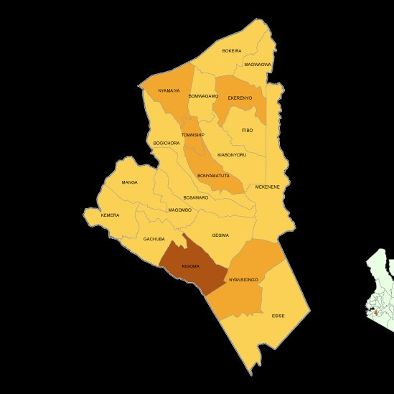

## 1.2 Background of the sector

Under the sessional paper No.6 of the Kenya health policy (2012-2030) mandates the sector with the following functions;

* Eliminate communicable diseases
* Provide essential healthcare
* Halt and reverse the burden of non-communicable diseases
* Reduce the burden of violence and injuries
* Minimize exposure of health risk factors
* Strengthen collaboration with sector providers

The health sector is comprised of two units’ medical services and public health and sanitation.

The department is run in three main programmes namely;

* **Preventive and promotive health** - responsible for making sure that there are no occurrences of disease and other health related problems. Also provides effective framework and Environment that support implementation of Health services
* **Curative and rehabilitative health** - responsible for curative and rehabilitative functions with key mandate of improving access to diagnostic and curative services hence reducing incidence of mortality and improved quality of life of individuals.
* **General administration and support services**- Responsible for financial management and provision of policy guidance and leadership for the prudent use of resources and ensures that the core functions of the department are effectively and efficiently executed.

## 1.3 Rationale for the County Sectoral Plan

The right to health is a fundamental human right guaranteed in the Constitution of Kenya. Article 43 (1) (a) of the Constitution provides that every person has the right to the highest attainable standard of health, which includes the right to health care services, including reproductive health care.

Like other plans within the sector the sectoral plan is expected to support implementation of the Vision 2030, CIDP III, Governor’s manifesto and the SDG’s goals and the broader goals of the Kenya Health sector. This plan will also form the basis for identifying deliverables under the performance contracting mechanism and for individual annual performance appraisal. The plan is also a resource mobilization tool. In addition, this plan will also inform the optimization of human resource required to facilitate a successful implementation of the mandate of the ministry. It tackles the health planning process such that the policy, outcomes and strategies of the Governors manifesto, CIDP III and the sustainable development goals which gives a better understanding of what is at stake in policy making hence address the specific issues and prioritize programmes to be implemented with focused attention. This helps get views and ideas from other government agencies, NGOs and civil society which will help to offer quality health services to the people better governance, public administration and prudent use of resources.

## 1.4 Approach/methodology in the preparation of the sector plan

A concept note was issued regarding the preparation of the sector plans. Then after a circular was circulated to departments by the budgeting and planning department to carry out public participation regarding the plan.

After the county cabinet approved the concept note, the governor went ahead to launch the exercise.

As a constitutional requirement, and advert was gazetted to give the public information on the venue, dates and issues to be discussed during public participation.

Afterward, a five-day consultation exercise to operationalize the various sector working groups was held in Best Western hotel. This forum was meant to develop the sectoral plans. Several stakeholders allied to the sectors were invited for consultations. A template for the sectoral plans was the shared by the National Treasury Planning department invited to the meeting to provide technical backstopping. The technical working group for the sector alongside the stakeholder went working into group to develop the sectoral plan. Various stakeholders were represented including the technical teams from the county government comprising the CEC Health services, CCO Health services, County directors of medical services, Public Health, Health planning and policy and Sub- County MOHs.

# CHAPTER TWO

# PERFORMANCE REVIEW OF THE PREVIOUS CIDP PERIOD

## 2.0 Introduction

This chapter provides a review on implementation of the previous CIDP 2018-2022. It presents an analysis of county performance in terms of revenues, expenditures and key outcomes as well as the major challenges faced in the implementation of the plan.

## 2.1 Analysis of the County Revenue Sources

This section should provide annual projected revenues versus actual receipts within the period under review. The information should be tabulated as in Table 1.

**Table 1 Analysis of County Revenue Sources**

|  |  |  |  |  |  |  |  |  |  |  |  |  |
| --- | --- | --- | --- | --- | --- | --- | --- | --- | --- | --- | --- | --- |
| **Revenue Sources** | **Revenue Projection (Ksh. million)** | | | | | | **Actual Revenue (Ksh. million)** | | | | | |
| **2018/2019** | **2019/2020** | **2020/2021** | **2021/2022** | **2022/2023** | **Total** | **2018/2019** | **2019/2020** | **2020/2021** | **2021/2022** | **2022/2023** | **Total** |
| Equitable share | 1,431,063,989 | 1,574,170,388 | 1,731,587,427 | 1,684,536,398 | 1,826,993,806 | **8,248,352,008** | 1,431,063,989 | 1,566,004,724 | 1,531,396,725 | 1,652,058,804 | - | **6,180,524,242** |
| b) Conditional grants (GoK) | - | 59,702,000 | 65,672,200 | 72,239,420 | - | **197,613,620** | - | 59,702,000 | 59,702,000 | 72,239,420 | - | **191,643,420** |
| c) Conditional grants dvp partners | 15,491,250 | 14,250,000 | 15,675,000 | 10,659,000 | 11,724,900 | **67,800,150** | 15,491,250 | 14,250,000 | 5,320,000 | 10,659,000 | - | **45,720,250** |
| d) Own Source Revenue | 98,774,960 | 135,273,640 | 148,801,004 | 82,801,004 | 91,081,104 | **556,731,712** | 98,774,960 | 135,273,640 | 75,273,640 | 203,846,931 | - | **513,169,171** |
| THSUC | 50,000,000 | - | - | - | - | **50,000,000** | 50,000,000 | - | 278,847,760 | 90,226,074 | - | **419,073,834** |
| e) Other Sources (unspent balance danida) | 6,500,000 | 7,150,000 | 7,865,000 | - | - | **21,515,000** | 6,500,000 | - | - | - | - | **6,500,000** |
| unspent bal. E.share | 368,634,048 | 405,497,453 | 446,047,198 | - | - | **1,220,178,699** | 368,634,048 | - | 116,186,650 | 51,123,597 | - | **535,944,295** |
| unspent bal. THSUC | 2,333,092 | 2,566,401 | 2,823,041 | - | - | **7,722,534** | 2,333,092 | - | - | 189,293,053 | - | **191,626,145** |
| User forgone fee | 13,175,221 | 14,492,743 | 15,942,017 | - | - | **43,609,981** | 13,175,221 | - | 13,175,221 | - | - | **26,350,442** |
| **Total** | **1,985,972,560** | **2,213,102,625** | **2,434,412,887** | **1,850,235,822** | **1,929,799,810** | **10,413,523,704** | **1,985,972,560** | **1,775,230,364** | **2,066,726,775** | **2,269,446,879** | **-** | **8,097,376,578** |

**Figure 2 Analysis of County Revenue Sources chart**

## 2.2 County Budget Expenditure Analysis

This section should provide an analysis of total budget allocation and total actual expenditure by sector. The information should be summarized as in Table 2.

**Table 2 Sector Expenditure Analysis**

|  |  |  |  |  |  |
| --- | --- | --- | --- | --- | --- |
| **FY** | **Total budget** | **Total actual expenditure** | **Variance** | **Absorption rate (%)** | **Remarks** |
| **2018/2019** | 1,985,972,559 | 1,782,625,853 | -203,346,706 | 89.77 | Delay in exchequer release |
| **2019/2020** | 1,891,525,342 | 1,793,102,956 | -98,422,386 | 94.80 | Delay in exchequer release |
| **2020/2021** | 2,109,810,202 | 1,833,506,720 | -276,303,482 | 86.90 | Delay in exchequer release |
| **2021/2022** | 2,299,126,991 | 1,660,566,314 | -638,560,677 | 72.23 | Delay in exchequer release |
| **2022/2023** | 1,842,940,021 |  |  | 0 |  |
| **Total** | **10,129,375,115** | **7,069,801,843** | **-3,059,573,272** | **69.8** | Delay in exchequer release |

## 2.3 Sector Programmes Performance Review

• In this subsection, in a narrative form discuss sector performance trends of the sector performance key outcomes (changes from baseline values at the end of CIDP implementation period) highlighting outputs that has contributed to the changes. Show gaps from the expected values/levels, and also making comparison with national statistics.

This section should provide key achievements by sector.

## 2.4 Achievements

In this planned period, the Curative and rehabilitative services aim to reduce incidences of mortality and improve quality of life of individuals, households and community by ensuring Maternal mortality reduced from 385/100,00 to 349 per 100,000 live births; infant mortality went down to 27 per 1000 live births from 58 per 1000 live births; proportion of deliveries conducted by skilled attendants increased from 52% to 72.8% and proportion of women of reproductive age (WRA) receiving family planning (FP) from 65% to 87.8%,four facilities with functional radiology units, establishment of a functional dialysis center,6 theatres completed and equipped,1 operational dental unit,1 ICU equipped,1 hospital with oxygen generating plant,111 facilities stocked with essential commodities and medical supplies, availability of 12 functional ambulances,21 new primary health facilities,10 motor bikes procured and installation of water tanks. These achievements can be attributed to recruitment of additional 573 staffs, opening of 27 new maternity units, enhanced referrals by community health workers, additional immunizing sites, community dialogue sessions with community gatekeepers as well as the Linda Mama Initiative.

The Promotive and preventive health services programme aimed to reduce incidence of preventable diseases and mortality in the county by ensuring a remarkable improvement in HIV interventions with the prevalence of HIV reducing to 3.9% from a high of 6.4% in 2017 due to concerted efforts that has been put over the years, a greater % of 77.8 women using modern family planning methods, construction of 24 staff houses in the Health facilities, operationalization of 27 maternity units,72% of births are attended to by skilled health personnel,95% of pregnant mothers are on insurance cover,86% of children are fully immunized, procurement of 24 vaccine fridge, in improving care, treatment and health promotion activities.

The general administration, planning and support services aimed at improving service delivery by providing supportive functions to implementing units under the health department by enactment of health policy and bill, recruitment of new 573 health workers, training of 576 health workers and procurement of 16 ICT equipment to aid in the performance of functions.

## 2.5 Challenges

This section highlights the constraints that prevented the programme from fully realizing set targets.

* Inadequate allocation of funds for recurrent expenditure
* Delayed completion of building projects due to internal and external factors
* Emerging issues eg covid 19
* Late disbursement of revenue from national treasury
* Inadequate human resource for health
* Unfavorable procurement policies e.g legislation to procure from KEMSA only, cumbersome procurement procedures
* Reducing donor funding due to change in international policies

## 2.6 Emerging issues

• This section highlights the unforeseen issues that arose during implementation period that needed or needs to be addressed.

Emerging diseases such as Covid 19 and other Severe Acute Respiratory Syndromes (SARS) interfered with service delivery thereby straining the health system. The threat of Ebola from nearby countries which requires re-organization of the health systems including allocation of more resources to heighten surveillance. There is also the triple threat amongst adolescent which includes: Increasing new HIV infections, teenage pregnancy and gender based violence which all calls for things to be done differently.

## 2.7 Lessons Learnt

* This section indicates the new knowledge gained during implementation of the previous CIDP, i.e. what worked and what did not work
* Digitalization of services increase revenue and improves service delivery
* Involvement of stakeholders in the developing plans and during implementation reduces political and community resistance
* Inter-sectorial collaboration is an important ingredient in project and programme completion in the health sector

## 2.8 Development Issues

This section should present key sector development issues and their causes as identified during data collection and analysis stage. The information should be provided as indicated in Table 3.

**Table 3 Sector Development issues**

|  |  |  |  |  |  |
| --- | --- | --- | --- | --- | --- |
| **Development Issue** | **Root Causes** | **Development Objective** | **Immediate Objective** | **Existing opportunities/ strengths within the sector** | **Strategies** |
|  |  |  |  |  |  |
| Health financing and leadership | Inadequate health financing | Increase health financing | Increased Health financing and  Reduce out of pocket expenditure | * Availability of Facility Improvement Fund (FIF) * Availability of funding through NHIF and other insurances | * Digitalise billing system * Increase number of services provided * Lobby for increased departmental allocation from treasury * Advocate on the increase on registration on NHIF * Registration of indigents and funding of their NHIF premiums |
| Inadequate policies and guidelines | Develop relevant policies and guidelines | Development of Policies and guidelines | * Availability of national policies and guidelines that can be customized | * Customization of national guidelines and policies * Enact the Revolving Drug Fund act |
| Health product and technologies | Poor preventative maintenance | Improve preventive maintenance | Medical equipment maintained | Availability of trained staffs | * Develop asset registers * Regular maintenance of vehicles, plant and medical equipment |
| Inadequate medicines and non-pharms | Strengthen medicine and non –pharms supply chain | Medicines and non pharms procured | Availability of guidelines for medicines | * Have in place commodity management system |
| Inadequate medical equipment | Procure medical equipment as per norm and standard | Medical equipment procured | Availability of equipment norms and standards guidelines | * Progressively equip all health facilities to attain norms and standards |
| Health information Research and development | Inadequate ICT infrastructure | Digitalise health services | Health services digitalised | Availability of digital platforms that can be utilised | * Roll out a robust Health Management Information System |
| Lack of research framework | Develop research framework | Research framework developed | Availability of trained staffs | * Institutionalize Research within the department |
| Health Workforce | Staff apathy | Improve staff welfare | Staff welfare improved | Availability of HRH manual | * Develop and implement staff motivation framework |
| Inadequate skills mix | Improve skills mix | Staff skills improved | Availability of trainers | Training through on job and in service |
| Inadequate staffing | Increase staffing | Staffing improved | Availability of trained staffs | Recruitment of additional missing staff |
| Service delivery and infrastructure | Inadequate specialized  services | Avail specialized services. | Specialised services offered | Trained specialists available | Completion of doctors plaza |
| Poor planned layout of health  Facilities | Adequately layout \facilities | Health facilities well planned | Availability of infrastructure norms and standards guideline | Follow norms and standards to construct health facilities  Strengthen collaboration with Public works |
| Increase NCD malnutrition | Reduce the burden of non communicable diseases and malnutrition | NCDs and malnutrition reduced | Availability of staffs and guidelines | Develop a cancer centre at NCRH  Early screening and detection of NCDs |
| Increase in Hiv/ communicable diseases/TB/ | Eliminate communicable diseases | Communicable diseases eliminated | Availability of trained staffs and guidelines | Health promotion |
| High maternal and neonatal deaths | Provide essential health services | Reduced maternal and neonatal deaths | Availability of trained staffs and guidelines | Conduct survey on causes of high maternal and neonatal deaths. |
| Weak community health systems | Strengthen community health systems | Community health systems strengthened | Availability of guidelines | Provide incentives to Community Health workers |
| Inadequate inspection, sampling and enforcement of public health issues | Strengthen provision of public health services | Public health services facilitated | Availability of trained staffs and guidelines | Carry out inspections of eateries and health facilities  Carry out food sampling in markets  Enforce public health laws |
| Lack of health facilities master plan | Develop health facilities master plan | Facilities master plans developed | Availability of trained staffs and guidelines | Facilitate health facilities to develop master plans |
|  | Weak collaboration with Health-Related Sectors | Develop collaboration framework with health-related sectors | collaboration framework developed | Supportive leadership in health-related sectors | Hold stakeholders meeting  Establish call centre |
|  | High exposure to health Risk factors within the County | Minimize exposure to health risk factors | Top 5 prevalent health risk factors mapped | Sensitized gatekeepers on health risk factors | Community health Education  Set up IPC committees in all facilities  AYSRH activities |
|  | High burden of Violence & Injuries | Reduce the burden of Violence & Injuries | Safer and quality livelihoods for Nyamira people | High awareness among State actors | Capacity build staff on emergency response  Create emergency response teams in all facilities  Community sensitization  Form a multi-sectoral TWGs  Construction of Accident and emergency centre at NCRH  Construction of GBVRC at NCRH |

# CHAPTER THREE

# SPATIAL PLAN FRAMEWORK

## 3.0 INTRODUCTION

This section, describes the spatial framework within which development projects and programs will be implemented, establishing a broad physical and Land Use Planning framework that provides spatial planning policies to support economic and sectoral planning.

## 3.1 SPATIAL DEVELOPMENT FRAMEWORK

The County Government of Nyamira‘s transformative agenda is anchored on socio-economic transformation aimed at ensuring that the quality of life is improved throughout the County. This transformative agenda sets outs the blue print for economic growth that covers all strategic development areas within the County. This vision can only be achieved if the development is anchored in sound GIS based Physical and Land Use Planning. As such, the Vision lays emphasis on spatial reforms, with the preparation of the County Spatial Plan and various areas Local Physical Development Plans.

The role of Land use planning and indeed the CSPs is explicitly outlined in the Constitution of Kenya Article 61 and 66, further County Government Act of 2012 which under section 110 (1)(a) stipulates that the County Spatial plans shall give effect to the principles and objects of planning and development contained in section 102 and 103 of the same Act. It also outlines that the CSPs should set out the guidelines for a land use management system in the County.

As espoused in the Physical and Land Use Planning Act of 2019, the preparation and implementation of the CSP will set the momentum for prudent utilization of County space, resources and inter-ministerial coordination. Further, the plan will facilitate the achievement of the land policy principles of efficiency, equity, sustainability and productivity, and promote the attainment of social, economic and environmental goals and objectives. Further, the Plan provides strategies and policies to deal with challenges including urbanization, regional imbalances/inequalities, rural under-development, environmental degradation, and underutilization of the massive resources available in the country.

The policy framework that the preparation of the CSP alludes to include; Sustainable Development Goals, New Urban Agenda, The Kenya Vision 2030, Medium Term Plans, Urban Land Use Planning and Oversight guidelines, national land use policy, national urban development policy, national spatial plan among others.

## 3.2 STATUS OF COUNTY PHYSICAL AND LAND USE PLANNING STATUS

Since the enactment of the Physical and Land Use Planning Act and establishment of the Nyamira Municipality, through the Planning authority, the Physical and Land Use Directorate, the County has prepared Nyamira Municipality Spatial plan to preparation of the final report, subject to the County Executive Committee Members ratification, County assembly approval to the eventual ascent by H.E the County Governor of Nyamira. Alongsie the MSP, the Planning Authority have prepared 9 Local and Physical Development Plans for major urban centers within Nyamira Municipality. The towns include, Nyamaiya, Miruka, Kioge, Nyamira Township, Sironga, Konate, Kebirigo, Ting’a and Nyaramba.

It shall be noted that the county has more than 70 upcoming urban centers with either have outdated plans or no plans and notably require urgent planning intervention to ensure coordinated development and appropriate sustainable investment for the prosperity of the people of Nyamira. This shall be given priority at the completion of the CSP strategic urban areas spatial and institutional development for wealth creation. The County Spatial Plan 2022-2032, after completion of the Inception Report, The situational Analysis Report, is at its third stage of Draft Plan Formulation before preparation of the Final Plan report for approval consideration stage.

## 3.3 COUNTY RESOURCE POTENTIAL GROWTH AREAS.

The CSP of the Situational Analysis of the economic systems is prudent for the understanding of human interactions, growth and development of an area. Kenya’s Vision 2030 is founded on the economic, social and political pillars. Being one of the pillars identified to guide the national agenda, the economy is therefore integral to any region’s growth and development. Accordingly, Nyamira County has a rich economic base founded on agriculture, mining, tourism and hospitality, agro-based industries as well as trade and commerce. The forgoing shall transform the County wealth and economy through focus on specific thematic identified and highlighted hereunder for modelling.

### 3.3.1 Physiographic Characteristics

Physical features play a critical role in the county development. Some of the features like rivers, wetlands, forests/hills and water falls are sources of livelihoods to the county residents. The county physiographic characteristics present both opportunities and challenges as outlined below:

**Map 3. Natural Features**

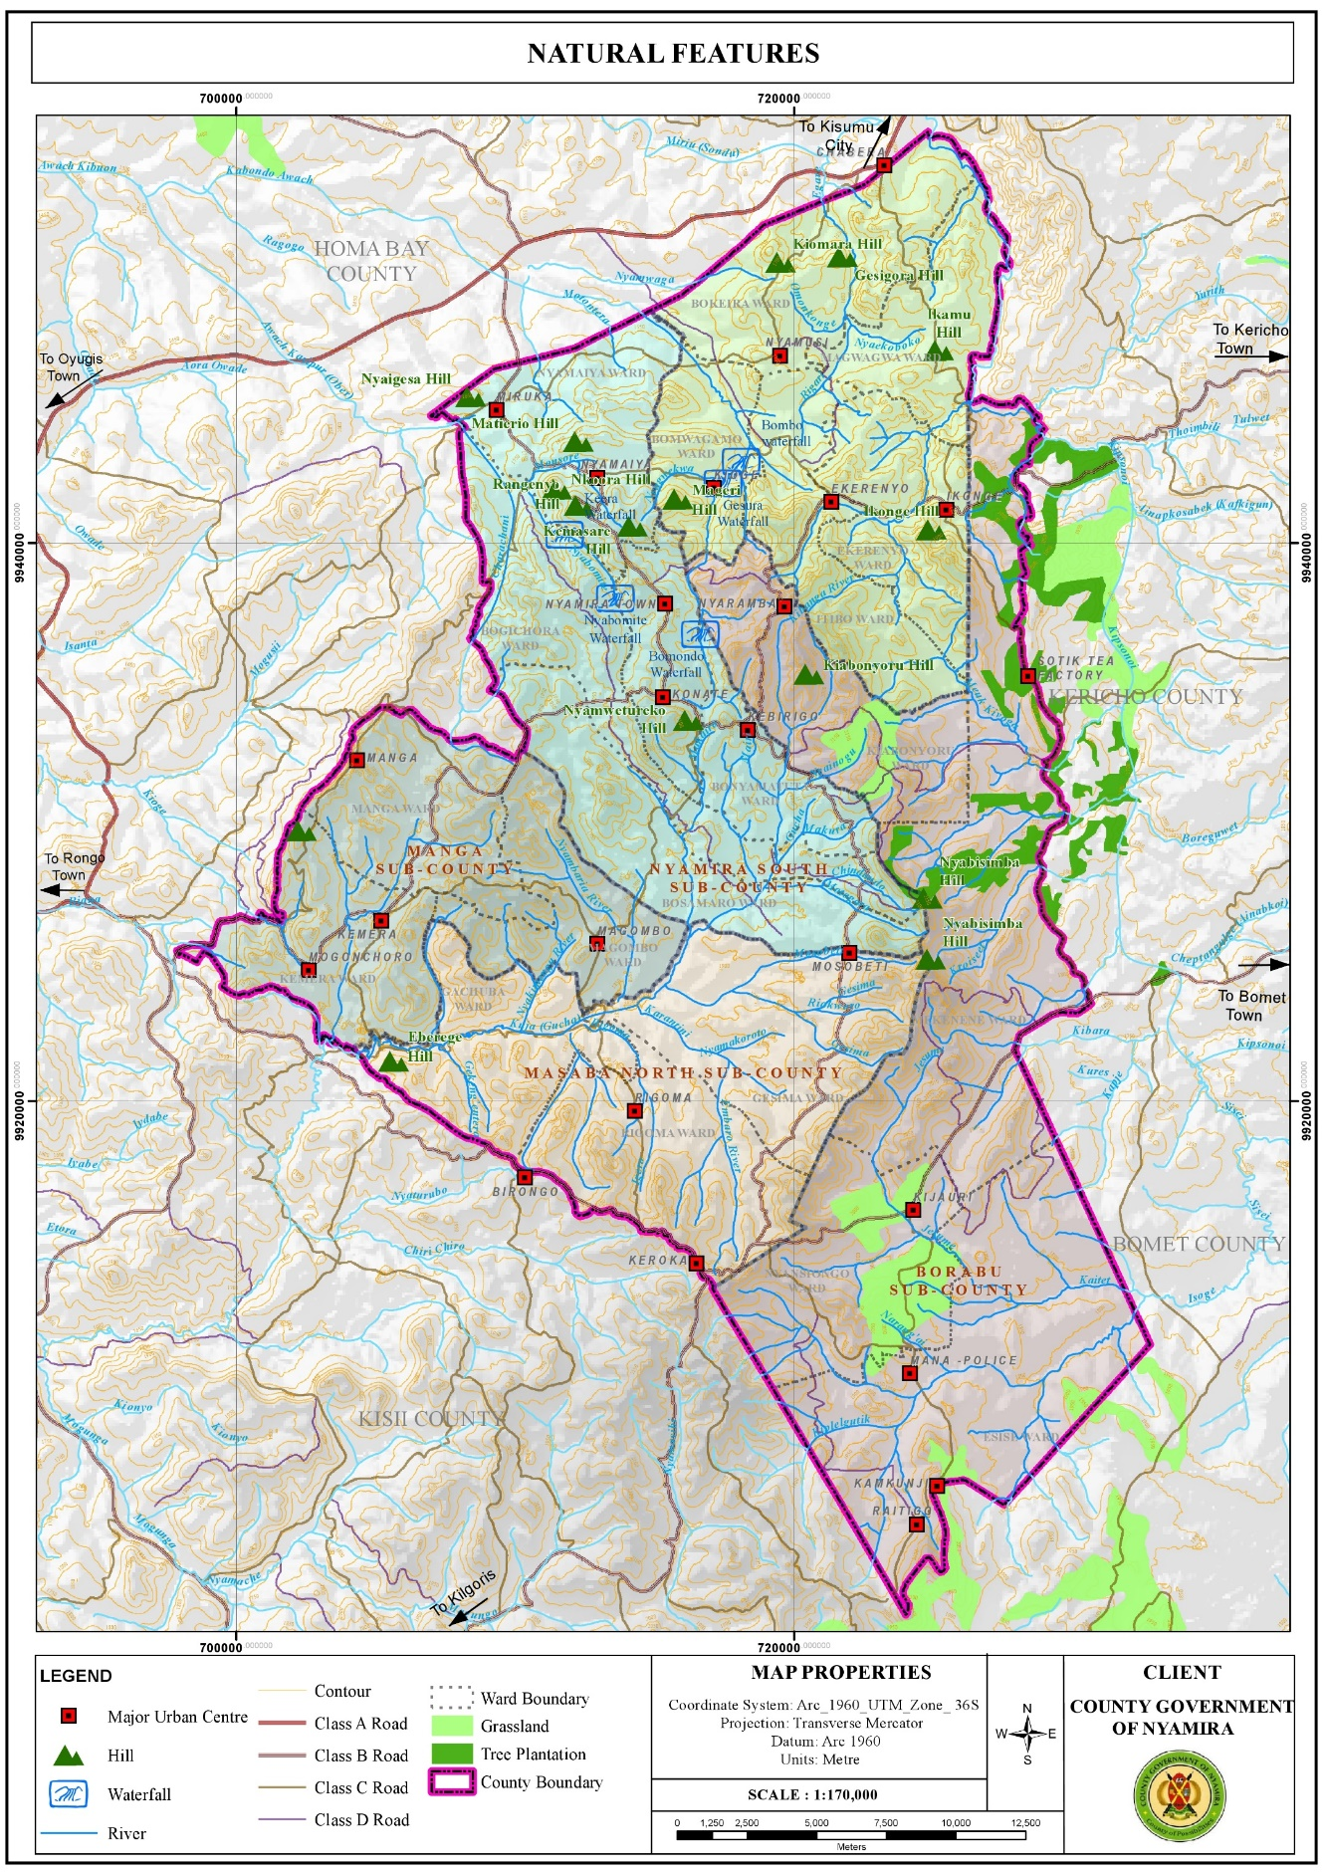

#### 3.3.1.1 Opportunities

1. Hydrology: The County is adequately drained by the four main rivers and their tributaries. There are also several springs, wetlands and few water falls which sustain the county’s hydrological cycle. In addition, the high-water tables in the county have enabled the digging of shallow wells and boreholes. These water resources are the main water sources in the county, for instance, the intake for Nyamira water supply is located at River Eaka. River Sondu on the other hand has a lot of potential for hydro-electricity power generation which if tapped could contribute greatly towards the economic development of the county. The presence of numerous rivers presents opportunities for water harnessing through river obstruction.
2. Favorable Climatic Conditions for Agricultural Activities: The county has a bimodal pattern of annual rainfall that is well distributed, reliable and adequate for a wide range of crops with annual rainfall ranging between 1200 mm – 2100 mm per annum. The cold temperatures in the county are ideal for the growth of certain crops like tea and coffee which grow better in relatively cold regions.
3. Suitable Ecological Zones and Fertile Volcanic Soils for Agricultural Activities: The county is divided into two major agro-ecological zones. The highland zone (LH1 and LH2) covers 82 per cent of the County while the upper midland zone (UM1, UM2 and UM3) covers the remaining 18 per cent. These zones are suitable for growing various crops among them; tea, coffee, bananas, maize, avocado, sugarcane, pineapple, sweet potato, pyrethrum etc. These suitable ecological zones coupled by the rich volcanic soils make the county one of the main food producers in the country exporting food commodities to the regional hinterland and the country’s capital. However, the economic viability of the agricultural sector is threatened by the diminishing land sizes resulting from unregulated subdivision mainly for inheritance purposes.

**Map 4. Agro-Ecological Zones**

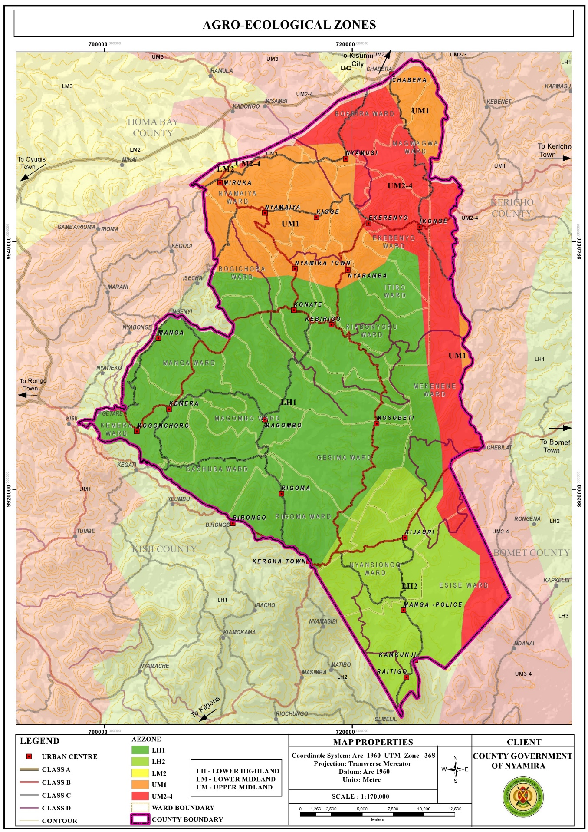

1. High Rainfall Amounts: The high rainfall patterns of between 1200 mm – 2100 mm per annum present opportunities for rain water harvesting through creation of large-scale runoff collection reservoirs and household rainwater harvesting. The harnessed water would be used during the relatively dry seasons of the year. If the harnessing is optimally undertaken, it would augment the terrain problems associated with piped water provision. Moreover, the rain water would reduce pressure on the natural water resources like springs, streams, rivers and wells which together supply water to about 80% of the population.

**Map 3. Rainfall Distribution Map**

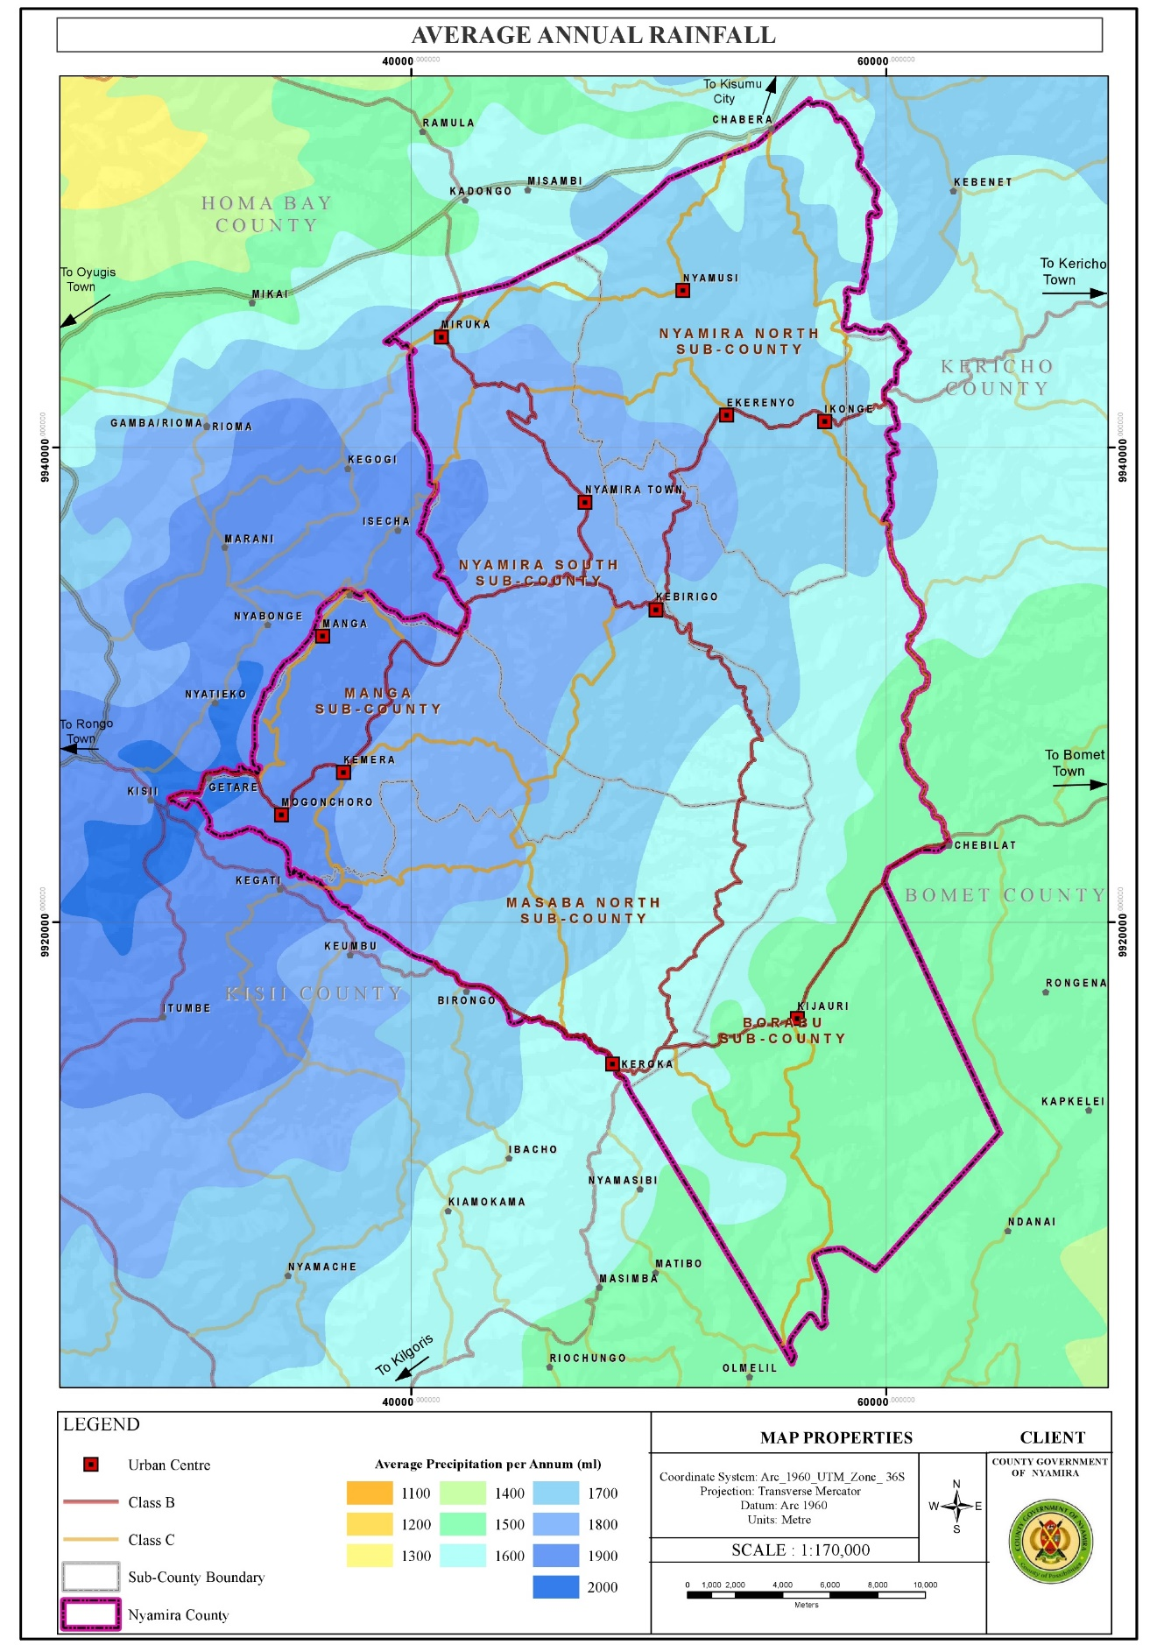

1. Renewable Energy: Harnessing like solar and wind though in small scale Nyamira County is relatively cold. However, the northern part of the county comprising of areas around Miruka, Nyamusi and Chabera have high solar potential with an annual solar photovoltaic power potential of between 1691 -1710 kWh/kWp. These areas also are the hottest with temperatures of 21.10C – 21.50C. The high temperatures in the northern part of the county coupled with high solar potential present an opportunity for solar power generation even at the household level. The county has an average wind speed of 2.46m/s which is beyond the cut-in-speed for small turbine to start generating energy which is set at 2m/s. However, the wind potential in the larger county is not at the required maximum of 10-15m/s with the exemption of the area around Manga ridge, an area near Birongo Market Centre in Masaba North Sub-County and an area near Ekerenyo Market Centre in Nyamira South Sub-County with relatively high wind power density of between 301 - 400 Watts per Square Metre. This wind power could be tapped to produce electricity.

**Map 4. Solar Potential Map**

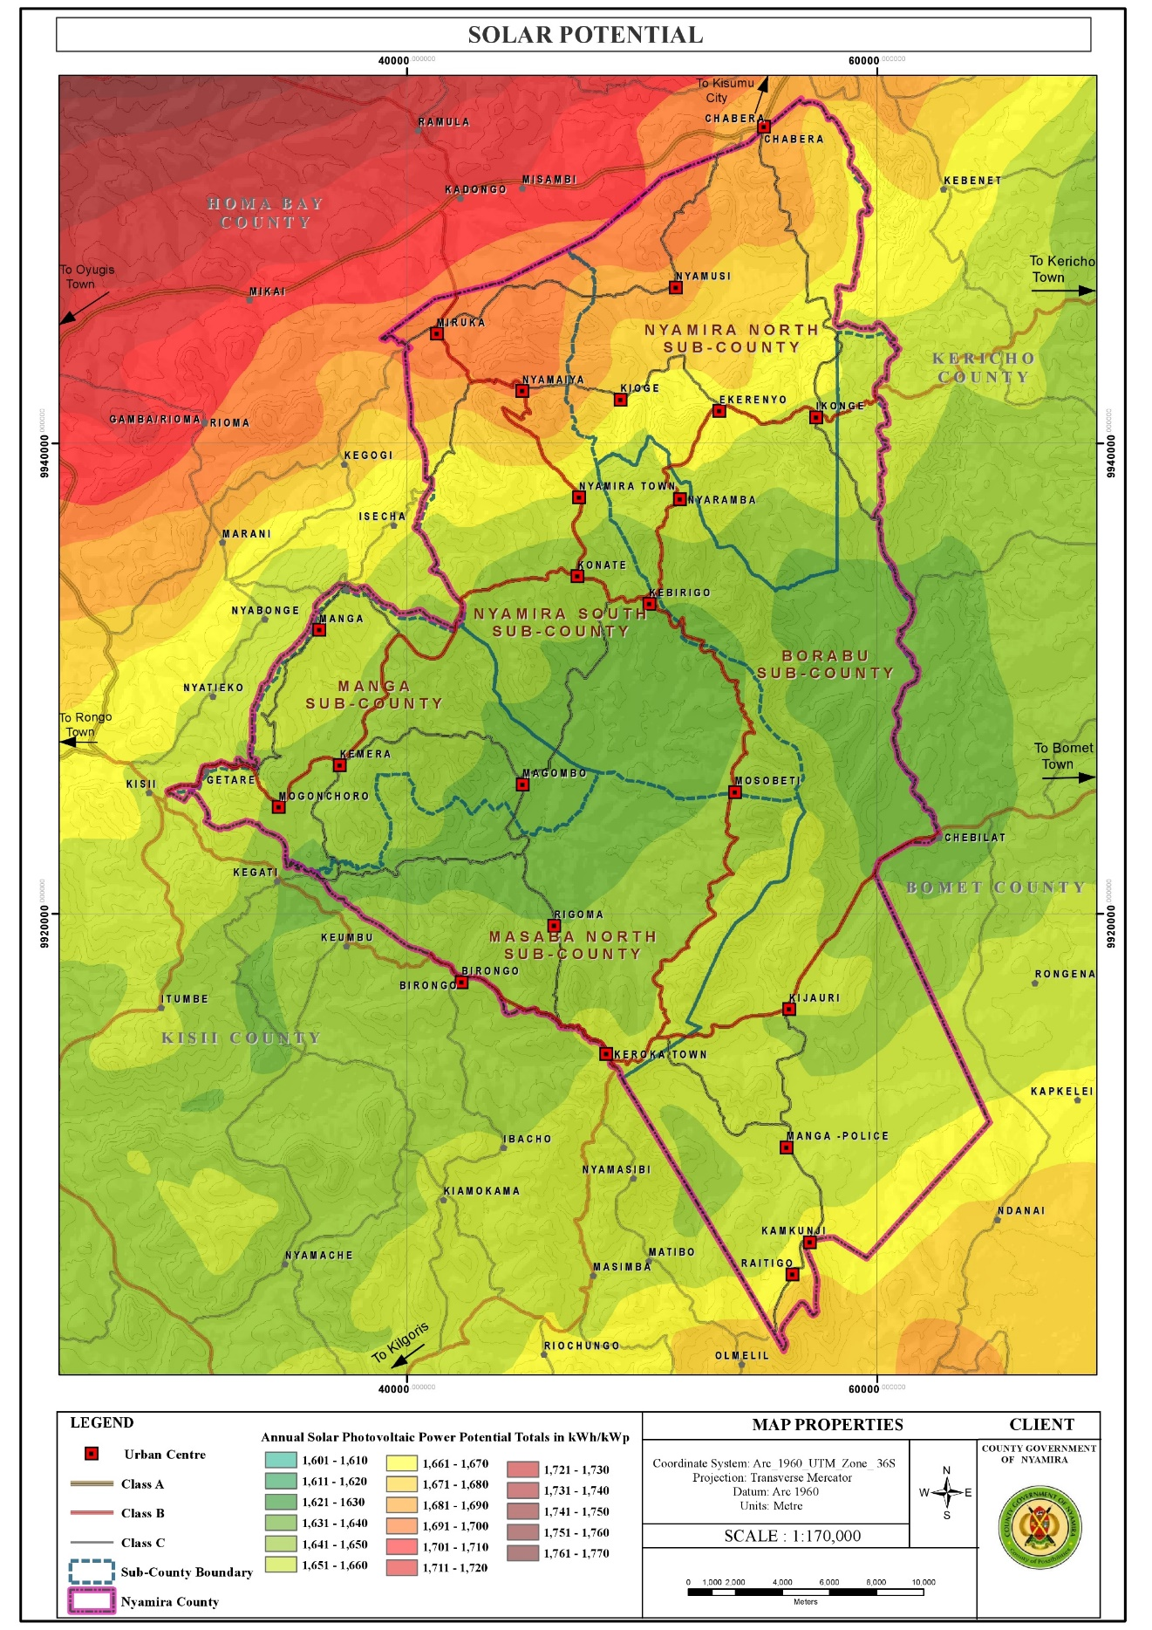

**Map 5. Temperature Distribution Map**

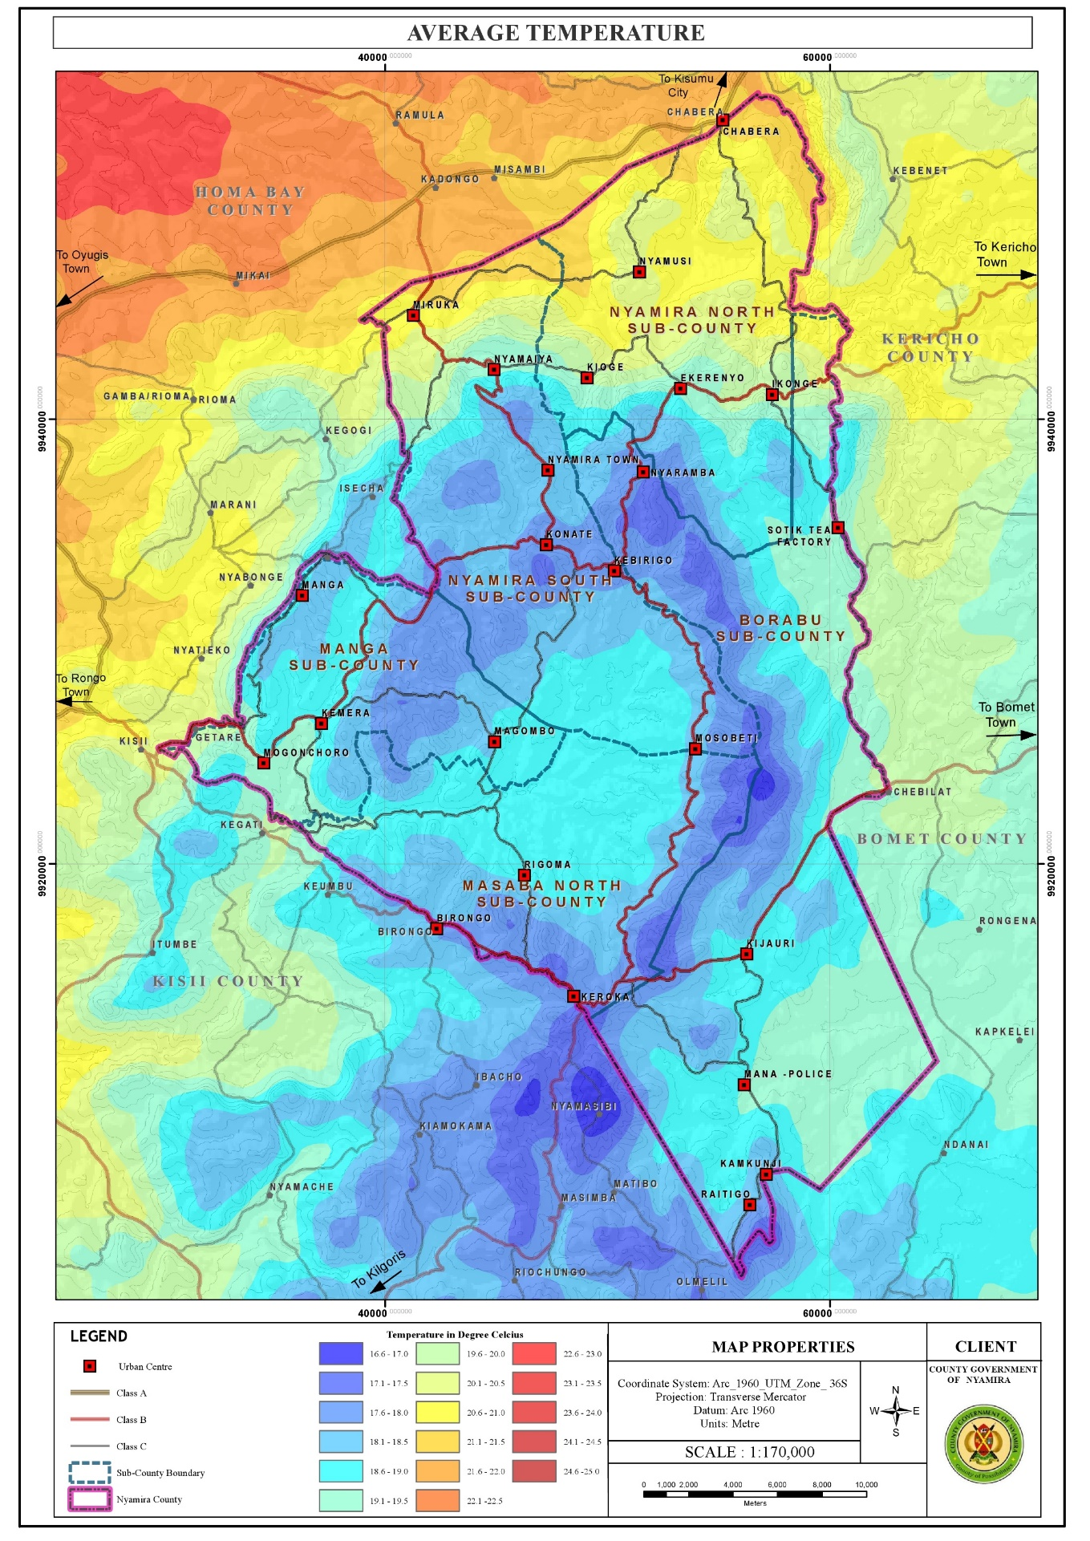

#### 3.3.1.2 Challenges

1. Depression of Water Levels: The water levels in the rivers, springs, streams and waterfalls have been depressing over time a phenomenon attributable to several factors among them, planting of inappropriate tree species along the riparian reserves and water catchment areas, improper farming methods, unregulated water obstruction upstream and the negative effects of climate change. These factors have resulted to reduction of water levels in the main rivers and drying up of the streams.
2. Unfavorable topography for construction: The rugged terrain in the county makes some areas inaccessible as construction of roads to certain places especially those on the hilly areas or low lands is an expensive undertaking. In addition, piping of the water from the various water sources in the low lands to the majority of the homesteads in the hilly areas is very costly, rendering it unfeasible. This forces the residents to access the water from their natural sources (springs and rivers).

**Map 6. Topography Map**

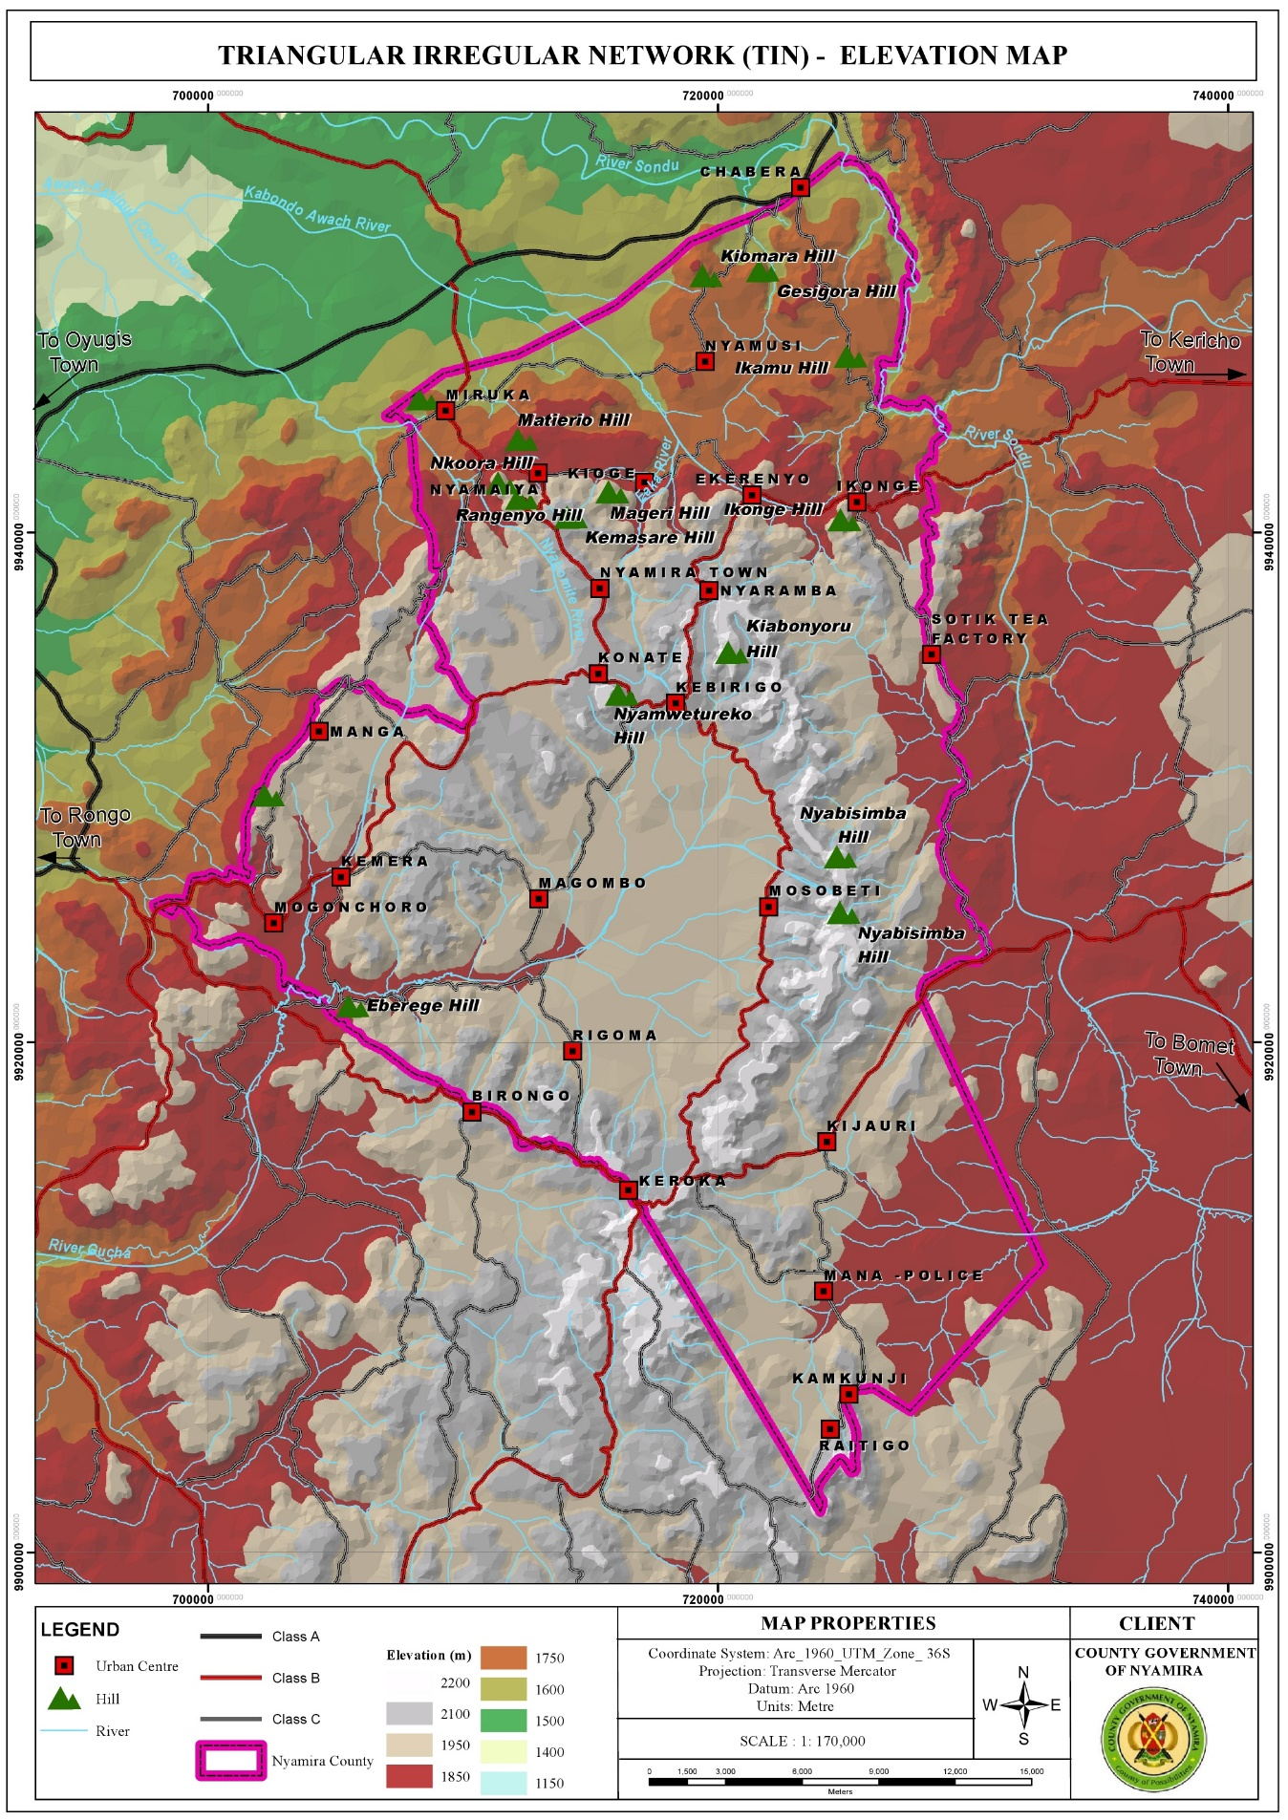

1. Poorly Drained Soils in Some Areas Resulting to Constrained Developments: A few areas in the county have poorly drained soils. These areas include sections of Magwagwa, Township, Bogichora, Bosamaro and Gesima Wards. They are characterized by red volcanic soils which are good for farming but make construction and road maintenance expensive. Thus, these areas are constrained in achieving high density developments.
2. Soil Erosion: Most of the rivers are characterized by brown waters, an evidence of soil erosion upstream. Soil erosion which displaces the fertile upper layer of the soil has negative implications on farm productivity as it results to reduced soil fertility. o High rainfall amounts The high rainfall amounts in the county coupled by increase in impervious layer make the county susceptible to flooding. The built areas especially those in the low lands face floods while the steep areas are susceptible to landslides especially in areas with loose soils.
3. Changing Weather Patterns: Changing weather patterns have affected all development sectors in the county with agriculture being the worst hit. The notable effects of this change are; delayed onset and untimely cessations of rain, skewed rainfall distribution and intensity and emergence of new pests and diseases.

### 3.3.2 Population and Demography

Population and demographic characteristics have far reaching implications on the county’s development. Various age cohorts present different needs with young population requiring the establishment of educational and health facilities. Youthful population requires focusing on youth empowerment programmes for skills and talent enhancement. To absorb the increasing labor force, investments in modern agricultural production and agro-based industries is necessary. The aged population on the other hand calls for allocation of resources for the provision of basic needs like water, food, clothing, shelter and medical services. The opportunities and challenges facing the county population are outlined below:

**Map 7. Population Density Map**

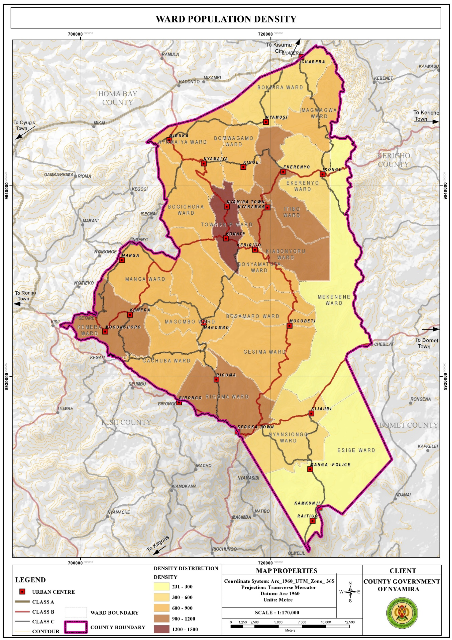

#### 3.3.2.1. Opportunities

1. High proportion of Youthful Population: The youthful population constitutes the largest segment of the county population as 72.44% is under the age of 35 years. The youths (15-35 years) in the county account for about 33.3% of the county population. This population requires massive investment in skill development. This presents opportunities for youth empowerment programmes for skills and talent enhancement.
2. High proportion of labor force: The labor force (15-64 years) constitutes about 55.8% of the total population. This calls for investment in diverse sectors like modern agricultural techniques and agro-based industries as well as creation of self-employment opportunities so as to absorb the increasing labor force
3. Development of Special Programmes : To address the needs of the elderly The aged population (65+ years) constitutes about 5% of the county population. This population presents opportunities in the provision of basic needs like food, water, clothing, shelter and health services so as to cater for the needs of this age group. In addition, this group presents opportunities for the development of special programmes and strategies.
4. High Literacy Levels for Basic Education: The county has relatively high literacy levels for basic education at 91.1% compared to the national literacy rate at 81.53%. However, only a small segment of the population has attained tertiary level of education as represented by 2.5% of the population.
5. Over reliance on agriculture as a source of income presents opportunities for investment in agricultural production programs. Agriculture is the economic backbone of Nyamira County providing employment and income for a large number of the people. In addition, the county is a food basket for the region and the country supplying food commodities to the Kenya’s capital, Nairobi.
6. High population is a market for good and services The county’s population is projected to be 629,287 people as at 2021 and 691,028 people by 2030. This population constitutes the immediate consumers of the goods and services produced in the county. It gives the primary motive of production as without consumption there wouldn’t be need for production.

#### 3.3.2.2 Challenges

1. Low number of population with tertiary level of education: The county has a very low proportion of the population who have attained tertiary level of education as represented by 2.5% of the population. This could be attributed to low transition levels from basic to tertiary education. Individuals with low literacy levels are more likely to experience fewer employment opportunities and outcomes thus lower incomes. As a result, they often face welfare dependency, low self-esteem and higher levels of crime. In Nyamira County, the low literacy levels in the male youths have pushed them to the boda boda sector leaving the agricultural sector with hardly no labor force. This reduces agricultural productivity. In addition, the high number of boda boda operators reduces the sector’s profit margin.
2. Overdependence in Agriculture as a Source of Livelihood: Agriculture is the main economic activity in the county employing a significant number of the population. This could be attributed to the low number of population with tertiary level of education; hence majority of the population lack the prerequisite skills to compete for the few white color jobs. The overreliance on agriculture is however not sustainable due to the diminishing and sizes resulting to uneconomical farm sizes. The reduced land sizes are as a result of population pressure especially in the denser areas as more agricultural land is being set aside for the construction of homesteads to house the growing population. In addition, intergenerational transmission of land rights that requires fathers to subdivide their property, land included to their heirs has resulted to unregulated land subdivisions. As a result, the emerging subplots are too small is some areas for any economical agricultural production. This has negative implication on individual households’ food and livelihood security.
3. High Proportion of Dependent Population: The county has a relatively high dependent population of 273,507 people as at 2021. This accounts for about 44.1% of the population and a dependency ratio of 79%. The county’s dependency ratio is relatively high compared to the national ratio of 69.8%. A high dependency ratio indicates more financial stress on working people as there is an increased burden to undertake child upbringing and pay pensions for the elderly.

## 3.3 Land and Land Use

Land and land-based resources facilitate social and economic developments as land is a requisite for all human undertakings. The opportunities and challenges regarding land are outlined below:

### 3.3.1 Opportunities

1. Large land parcels in Esise and Mekenene Wards in Borabu Sub-County Nyamira County is characterized by small scale farms with average farm sizes of 0.7Ha with the exemption of Esise and Mekenene Wards with large scale farm holdings of average farm sizes of 4 Ha. The farms in Mekenene Ward are owned by multinational companies while local individuals own the farms in Esise Ward. These large farms sizes present opportunities for large scale production hence the farmers can reap form the benefits of economies of scale.
2. High proportion of arable land The county has a high percentage of farmland as about 88.2% of the land is planted. This comprises of 64.5% under farmland and 23.7% under tree cover. This implies that, a great proportion of the county land is suitable for farming activities.

**Map 8. Land Use Classification Map**

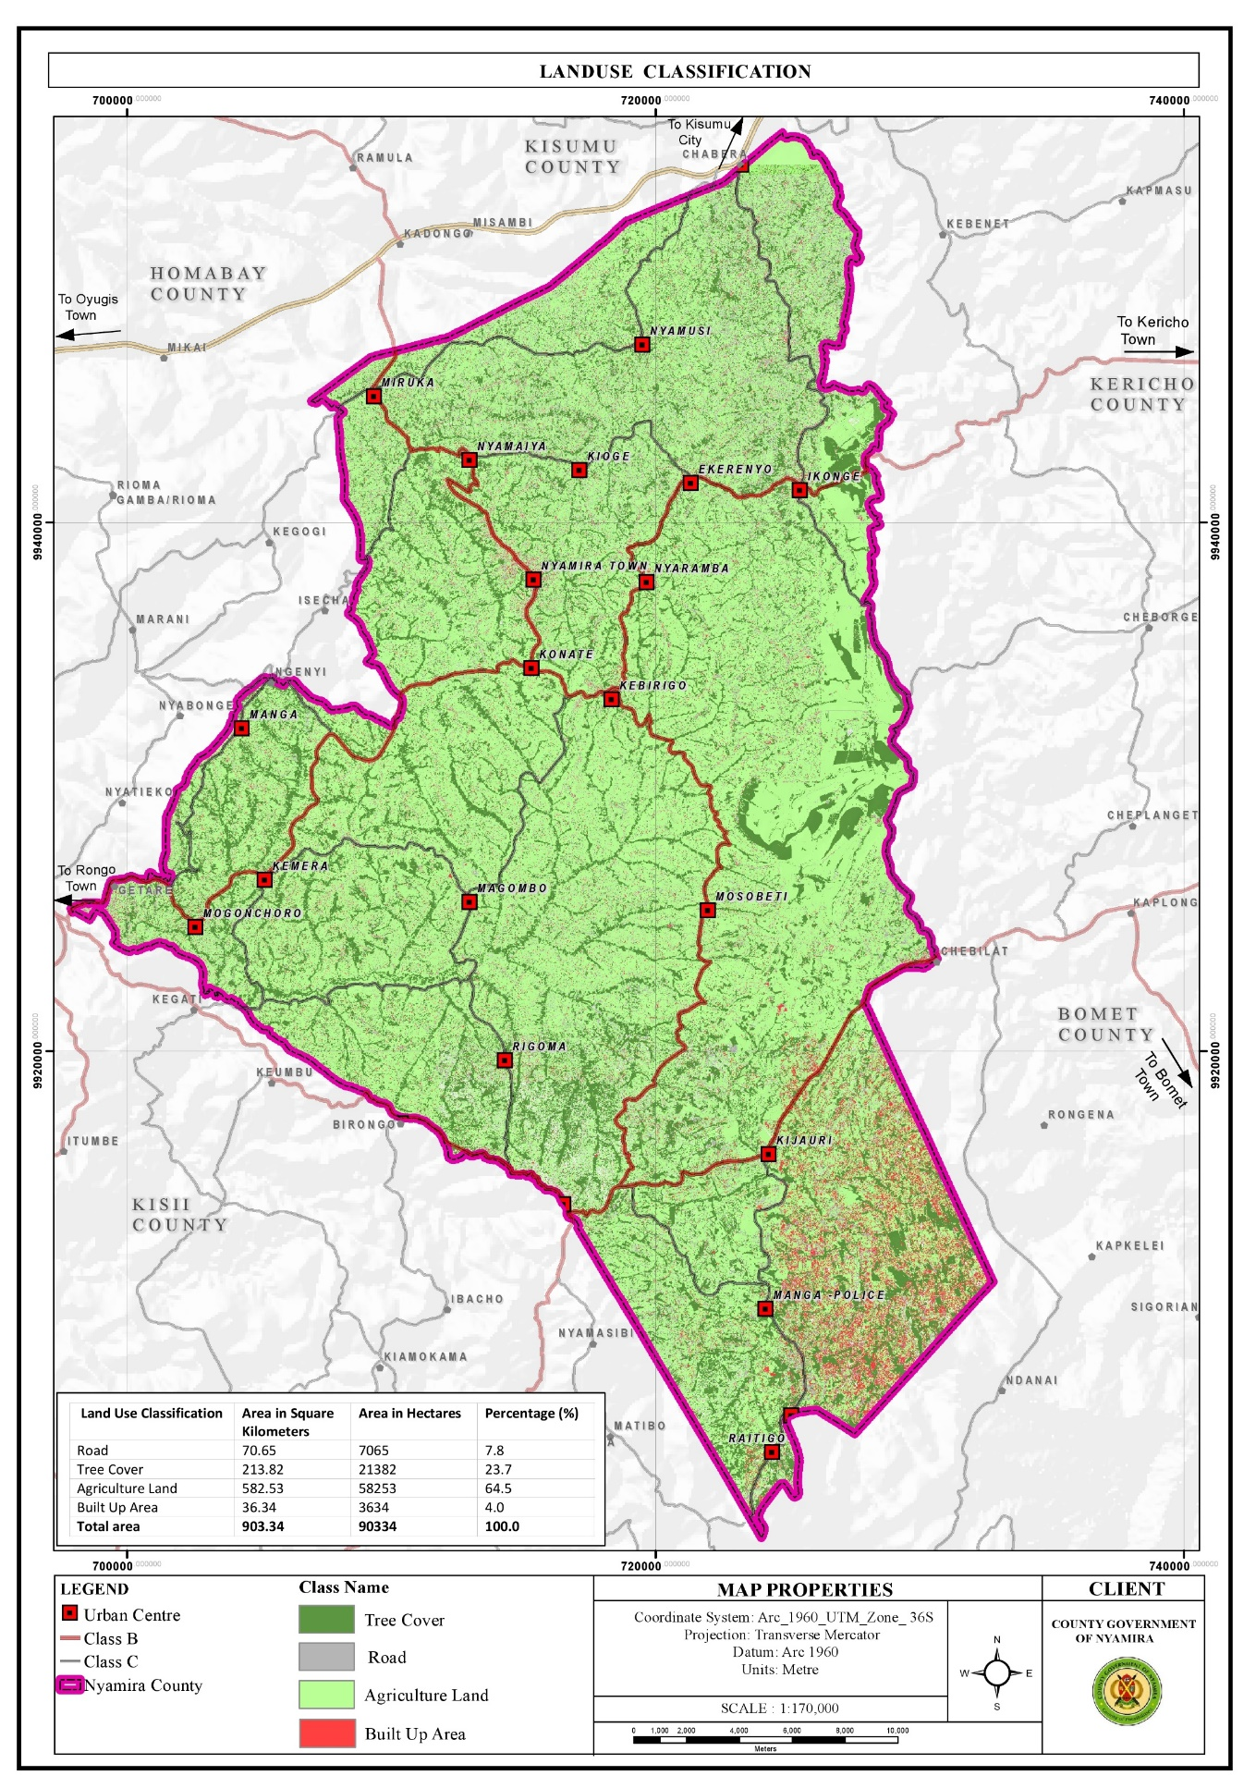

### 3.3.2: Challenges

1. Private land ownership: More than 90% of the county’s land is under freehold and comprises of the rural hinterland. The prevalence of private land ownership makes implementation of county development projects costly due to land acquisition and compensation costs.
2. Unregulated land subdivision: There has been significant land subdivision activities over the years mainly for inheritance purposes as the African culture and traditions dictate that fathers have to subdivide the property, land included to their heirs. Gradually, this practice coupled with population pressure has resulted to uneconomical land holdings
3. Freehold land ownership rights in most parts of the county, freehold land ownership rights are held at extended family where a family title is held in the name of the great grandparents. This poses challenges in succession, land managemet and administration.
4. Land use changes where urban developments are eating up agricultural land Changes in land use patterns are linked to a rapidly increasing population in the rural areas. This growth rate translates to an increased pressure and demand for land resources. The agricultural farms surrounding the towns and market centres are under massive pressure as the land parcels adjacent to the urban centres are gradually being converted to urban land uses. This threatens the sustainability of the agricultural sector in these areas as agricultural land use can’t be high for land as compared to commercial and residential land uses. O
5. Land fragmentation Land fragmentation in the county has been as a result of inheritance practices where all the heirs want to own land parcels both along the road and the riparian reserves. In addition, the small land sizes have forced the well up farmers to purchase or rent additional farm lots away from their original farms to add to their production levels. These fragmented land holdings have negative implications on agricultural production and food security due to the time lost accessing the fragmented parcels. There are also instances of increased disputes with neighbors.

## 3.4 Environment and Natural Resources:

Nyamira County has several ESAs which include green and open spaces, wetlands, hills/forests and water falls. These ESAs undertake key functions in the sustainability of the environment among them provision, regulatory, economic and cultural functions. They are however threatened by several human activities among them; farming, mining and construction. Opportunities and challenges affecting the environment and natural resources in the county are outlined below:

### 3.4.1 Opportunities:

1. High tree cover: The county has a relatively high tree cover of 35% compared to the recommended national minimum cover of 10%. Trees aid in; air purification through carbon sequestration, soil stabilization and protection from soil erosion, provision of timber and wood fuel and flood mitigation as the roots help in water infiltration to the ground.
2. Availability of several natural resources: The county is endowed with several natural resources like rivers, forest/hills, wetlands and water falls which provide opportunities for conservation, eco-system service provision and promotion of tourism.
3. Conducive climatic conditions for the thriving of these natural resources: The thriving of these natural resources is facilitated by the prevailing conducive climatic conditions in the county.
   * 1. **Challenges**
4. Planting of inappropriate tree species: Majority of the riparian reserves are planted with eucalyptus trees. Eucalyptus trees are widely grown and utilized throughout the world as they are a valuable source of timber and wood fuel. These tree species however deplete groundwater, dominate other tree species and cause loss of soil fertility. They are indeed a key contributing factor to the drying up of some streams and reduction of water levels in some rivers.
5. Deforestation: Despite the high forest cover of 35%, the county suffers from significant deforestation activities. This is mainly as a result of overreliance of wood fuel and the need for other wood products like timber. The county relies mainly on wood fuel for cooking with about 84.3% using firewood and 3.5% using charcoal for cooking. Apart from household wood fuel consumption, the tea factories in the county use firewood to process the tea leaves. In addition, several institutions like schools use firewood for cooking. Furthermore, due to the population pressure in the county, individuals are clearing trees to pave way for settlements and crop farming so as to house and feed the increasing population respectively.
6. Boundary tree planting conflicts: Planting of trees along the farm boundaries is a common practice in the county. Trees are used to demarcate the farm boundaries and in some instances, due to the small land sizes, there are no land parcels left for tree planting and farmers are forced to utilize the farm edges. In addition, competition for land with other farm land use allocations pushes tree planting to the edges as the little available land is allocated to production of staple food. This practice has resulted to significant conflicts as farmers on both sides want to utilize the edges for tree planting.
7. Encroachment of riparian reserves and forests: Rapid human population growth and overexploitation of resources are the main causes of land use and land cover change along river basins. In addition, agricultural land and urban settlements have increased at the expense of forests and grasslands. The conversion of land use and land cover into agricultural land and urban settlements has resulted to various environmental consequences like loss of ecosystem integrity, ecosystem imbalance and below optimum provision of ecosystem services.
8. Poor waste management causing pollution on the rivers: Most of the market centres do not have designated solid waste collection and disposal sites. This has led to sprouting of illegal disposal sites in the market centres as well as indiscriminate waste disposal. The disposal sites are also poorly managed. The poor waste management practices in the county cause significant pollution of the rivers as the waste is swept by surface runoff into the rivers. In addition, about 95% of the households use pit latrines for human waste disposal. The use of pit latrines impacts negatively on the quality of the underground water. The threats are even higher in flood prone areas where these latrines can contaminate surface run off. The health threat of this mode of waste disposal is alarming as about 80% of the population in Nyamira County depend on springs, streams, rivers and wells as the main water sources for their domestic use.
9. Environmental degradation: Environmental degradation in the county is as a result of unsuitable farming methods, effects of climate change, poor solid waste management, soil erosion, deforestation, quarrying activities and invasive species. o Floods and landslides The county is susceptible to flooding and landslides due to the high rainfall amounts experienced in the county coupled with increase in impervious cover.
   1. **Human Settlements and Urbanization**

Human settlements play a critical role in development as they are centres of social interactions, services and utility provision. These settlements are influenced by several parameters among them climatic conditions, infrastructure networks like roads, water and electricity as well as availability and access to gainful employment. Migration of rural population to major towns in search of employment and other services like education and health has resulted to strained infrastructural facilities in these urban centres. The human settlements and urbanization trends in the county present several opportunities and challenges as outlined below:

### 3.4.1 Opportunities

1. Strategic location: The county is located within the LREB among other 13 counties with similar ecological zones, natural resources and analogous cultural histories. The county benefits from the synergist links among the other counties in the bloc. In addition, majority of the towns and market centres are situated along transportation corridors, enhancing their accessibility.
2. Dense settlements provide ready market for products and are cheaper to service Consumption is the main motivation for production, as there won’t be need for production without adequate consumption. The dense populations both in the rural and urban centres translate to demand for goods and services. These dense settlements are also cheaper to service compared to linear and leap frog developments.
3. High percentage of home ownership at 85.5% The county has relatively high percentage of home ownership at 85.5% compared to the national percentage of 61.3%. This could be attributed to the fact that majority of the population resides in the rural areas where they have constructed their homesteads within the agricultural farms.
4. Manga Sub-County is earmarked for the development of housing under the big 4 agenda. Affordable housing is one of the Government’s big 4 agenda with the others being food security, manufacturing and affordable health care. The implementation of the housing project in Manga Sub-County is expected to propel investment in other sectors and spur the area’s economic growth.

**Map 9. Urban Extents**

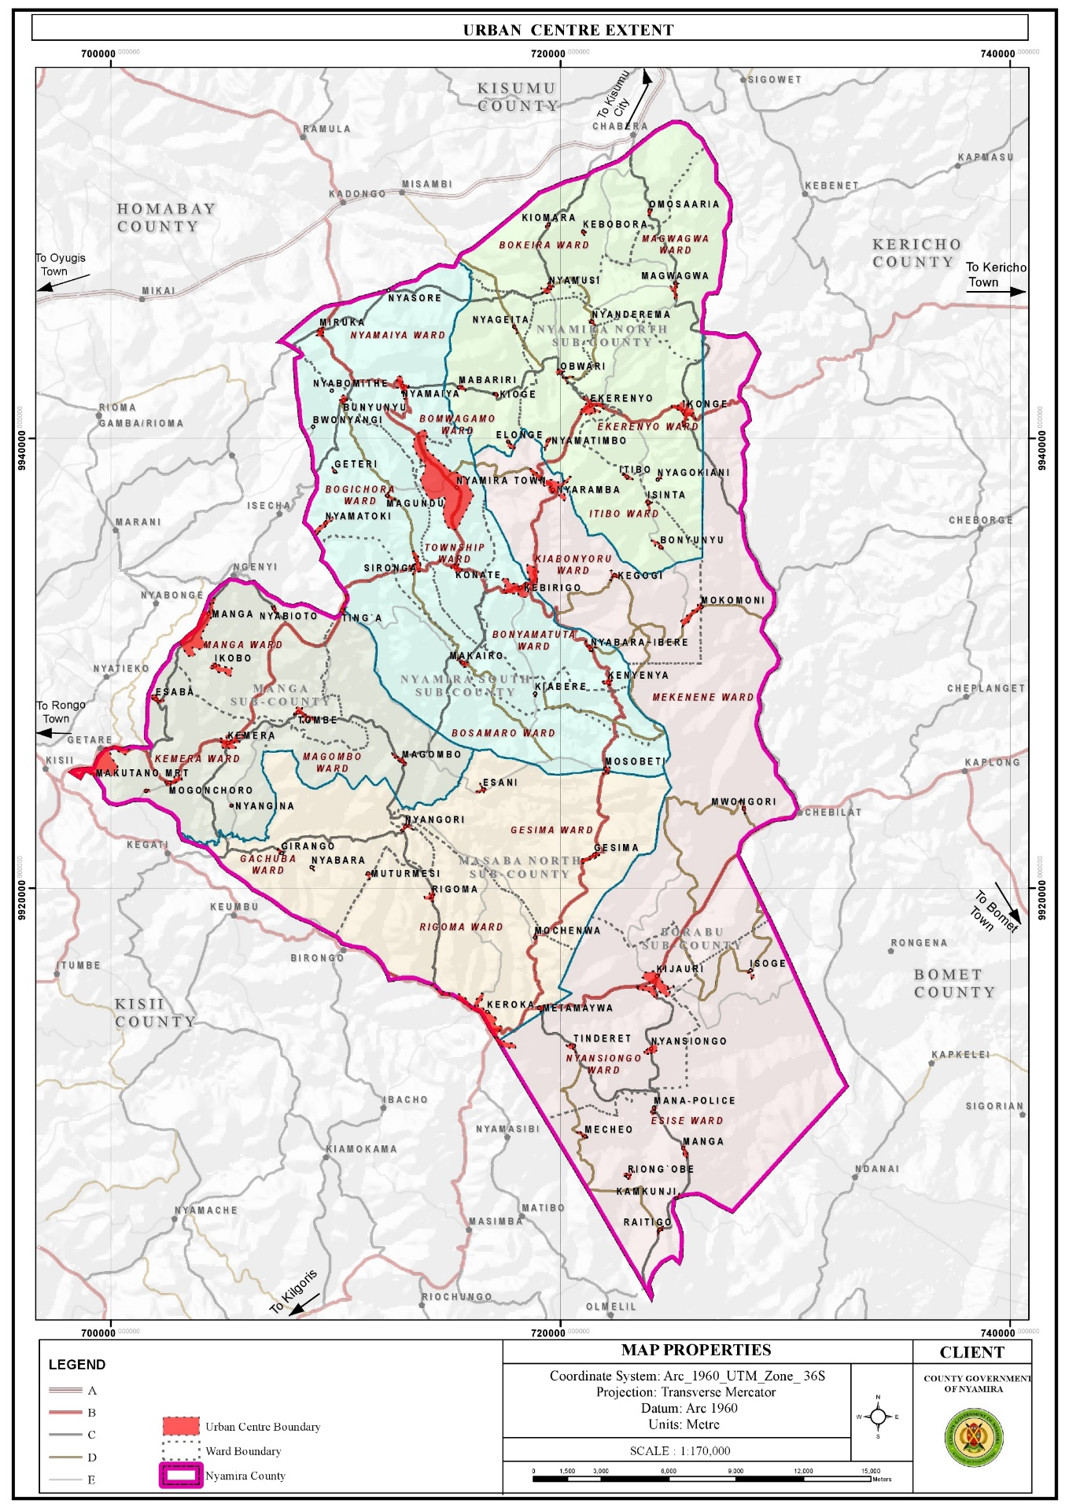

### 3.4.2 Challenges

1. Linear and leapfrog developments: Most market centres have developed along the major roads resulting to linear and leap frog developments. These developments are expensive to service.
2. Haphazard developments, urban decay and poor aesthetics of the market centres The towns and market centres in the county developed without any spatial framework to guide their development. As a result, majority of the centres are characterized by haphazard developments. In addition, the centres are not planned with the exemption of Nyamira Town, Miruka, Nyamaiya, Kioge, Ting’a, Sironga, Nyaramba, Kebirigo and Konate Market Centres though the plans are yet to be implemented. Some of the structures in the towns and market centres are in a dilapidated state as they are characterized by ugly walls and corroded roofs.
3. Poor solid waste management results to poor aesthetics in majority of the urban centres.
4. Limited accessibility and connectivity of the market centres Majority of the roads connecting the market centres are gravel and earth roads. The earth roads are in deplorable condition especially during the rainy season.
5. Inadequate land for future expansion of the urban centres as they are surrounded by freehold farm holdings. Majority of the market centres in the county were established by the former councils who identified public lands for potential growth of these centres and defined their boundaries.
6. Terrain The rugged topography in most of the urban centres has been a major limitation to their growth and development. For instance, construction of roads to certain places especially the hilly and low lands is costly and unfeasible in some areas. This renders some areas inaccessible. In addition, piping of the water from the various water sources in the low lands to the majority of the homesteads in the hilly areas is very costly, rending it unfeasible.

## 3. 5 Transport, Infrastructure and Services

Efficient transport, infrastructure services and utilities are prerequisite to socio-economic growth and development. The roads open up resource potential areas, link activity spaces and enable the circulation of goods and services. Water, ICT, energy, sanitation services and social infrastructure function towards uplifting the quality and standards of life for the county residents. This sector is presented with numerous opportunities and challenges as outlined below;

### 3.5.1 Opportunities

1. High connectivity of the county to the regional hinterland via the existing road network in the region: The county is well connected to the hinterland with Kisii-Chemosit road (B4) and Konate-Senta Road (B5) being the main roads connecting the county with other regions. Other roads linking Nyamira County to the rest of the region are; Narok – Kisii (B3), Kisii – Nyamira road (C21), Kisumu – Kisii Road (A1), Oyugis – Kendu Bay Road (C26), Kisii- Rongo Road, Kaplong – Chemasit – Kericho Road, Kericho – Kapsoit – Awasi – Ahero Road, Kebirigo – Ekerenyo – Ikonge – Chemosit Road, Ikonge – Magwagwa – Chabera Road among others

**Map 10: Road Network and Classification**

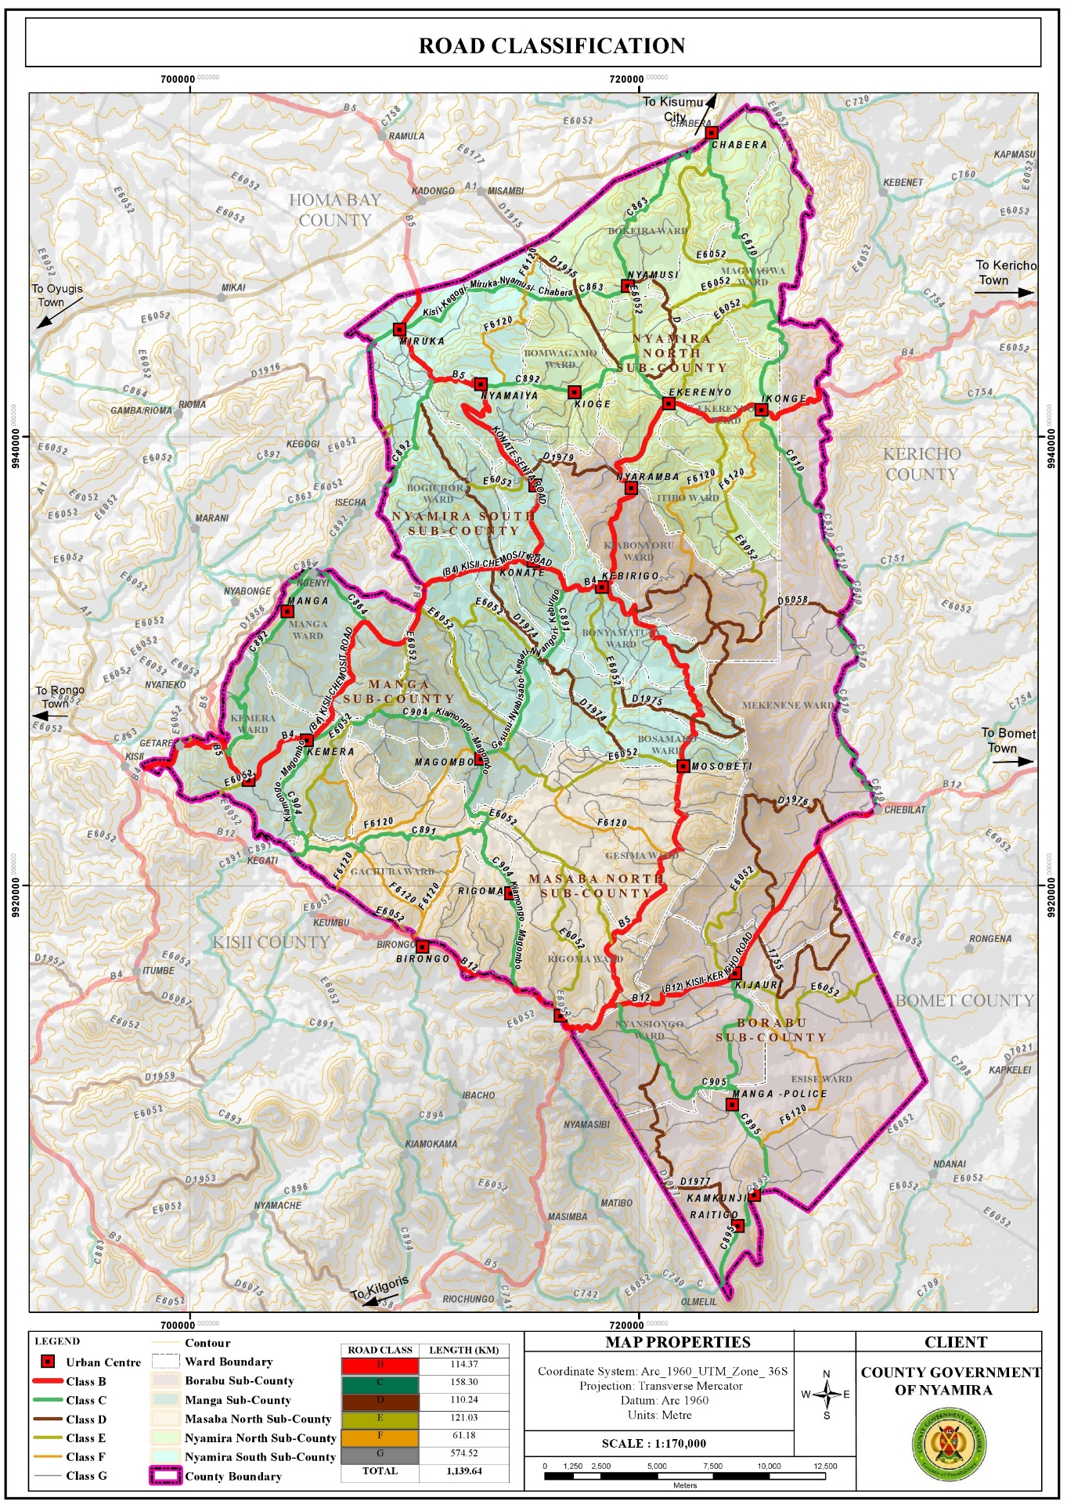

* + 1. **Challenges**

1. Poor road conditions: The county is characterized by poor road conditions with only about 20.1% of the classified roads being of bitumen surface type. About 27.6% of the roads are unclassified and are mainly earth roads. In Bosamaro Ward, for instance all the roads are earth roads. Majority of the gravel roads on the other hand are in poor condition due to poor maintenance and constant erosion of the top surface. The poor road condition especially for the earth roads renders them impassable during the rainy seasons. This poses a challenge in the transportation of farm inputs and produce.
2. Encroachment of road reserves: Majority of the road reserves have been encroached by informal businesses in the urban centres bringing about issues of space contestation between the road users, traders and customers. o Lack of bus terminus and parking spaces Most of the market centres in the county lack bus terminus with the exemption of Nyamira Town, Keroka Town and Ekerenyo Market Centre. This forces the Public Service Vehicles (PSVs) to load and offload along the roads. There are also no parking spaces in the urban centres and motorists are forced to park along the road reserves or building pavements.
3. Poor connectivity between the market centres : Despite the existence of roads connecting all the market centres, some of the roads are in a sorry state. The situation is further aggravated by missing bridges and poor conditions of the available bridges in some of the roads. This makes accessibility to some of the market centres a challenge.

## 3.6 ICT

### 3.6.1 Opportunities

1. Relatively high ICT proficient population: About 45% of the county population own mobile phones, 16% utilize the internet while 7% use laptops, tablets, computers and desktops. This presents opportunities for engagement in ICT related businesses.
2. Easier accessibility of ICT equipments : Accessibility to ICT equipment has become easier over the years since their introduction in the country. There are several electronic shops in the county headquarters (Township) where the county residents can access various devices at their convenience.

### 3.6.2 Challenges

1. Low budgetary allocation and inadequate staffing to operate the ICT infrastructure. o Inadequate skills in the ICT sector among staff in the county departments coupled by lack of training programmes to equip the staff with the required skills.
2. Low network reception in some areas, especially the low land areas as reception is hindered by the hilly areas. The residents have to move to higher grounds in search of network reception o Lack of resource centres, GIS lab and equipment for data storage and retrieving

## 3.7 Energy

### 3.7.1 Opportunities

1. Renewable energy sources: The Northern parts of the county comprising of the areas around Miruka, Nyamusi and Chabera have high solar potential that can be harnessed for solar power generation even at the household level. The area around Manga ridges, an area near Birongo Market Centre in Masaba North SubCounty and an area near Ekerenyo Market in Nyamira South Sub-County with relatively high wind power density of between 301 - 400 Watts per Square Metre are potential areas for wind power generation. There is also potential for production of biomass for cooking, though at household level. Tapping into these renewable energy sources could help minimize the negative effects of climate change.
2. Last mile connectivity : This presents an opportunity to connect other areas with electricity. 11.7.3.2 Challenges o Over-reliance on wood fuel for cooking Wood fuel is the main source of cooking energy with 84.3% and 3.5% of the population using firewood and charcoal respectively. In addition, the tea factories in the county use firewood for the processing of tea leaves. The use of wood fuel has implications on the environment as it leads to air pollution and reduction in tree cover.
3. Low electricity reticulation as some of the areas are not connected to the national grid : The current electricity coverage in the county stands at 49.5% which translates to about 85,548 connections. There are areas without electricity connectivity in the county like; Obwari, Gesura, Ensoko and Kiabora. These areas need to be connected to the national grid as electricity is a major component of socio-economic development.

**Map 11: Electricity Reticulation Map**

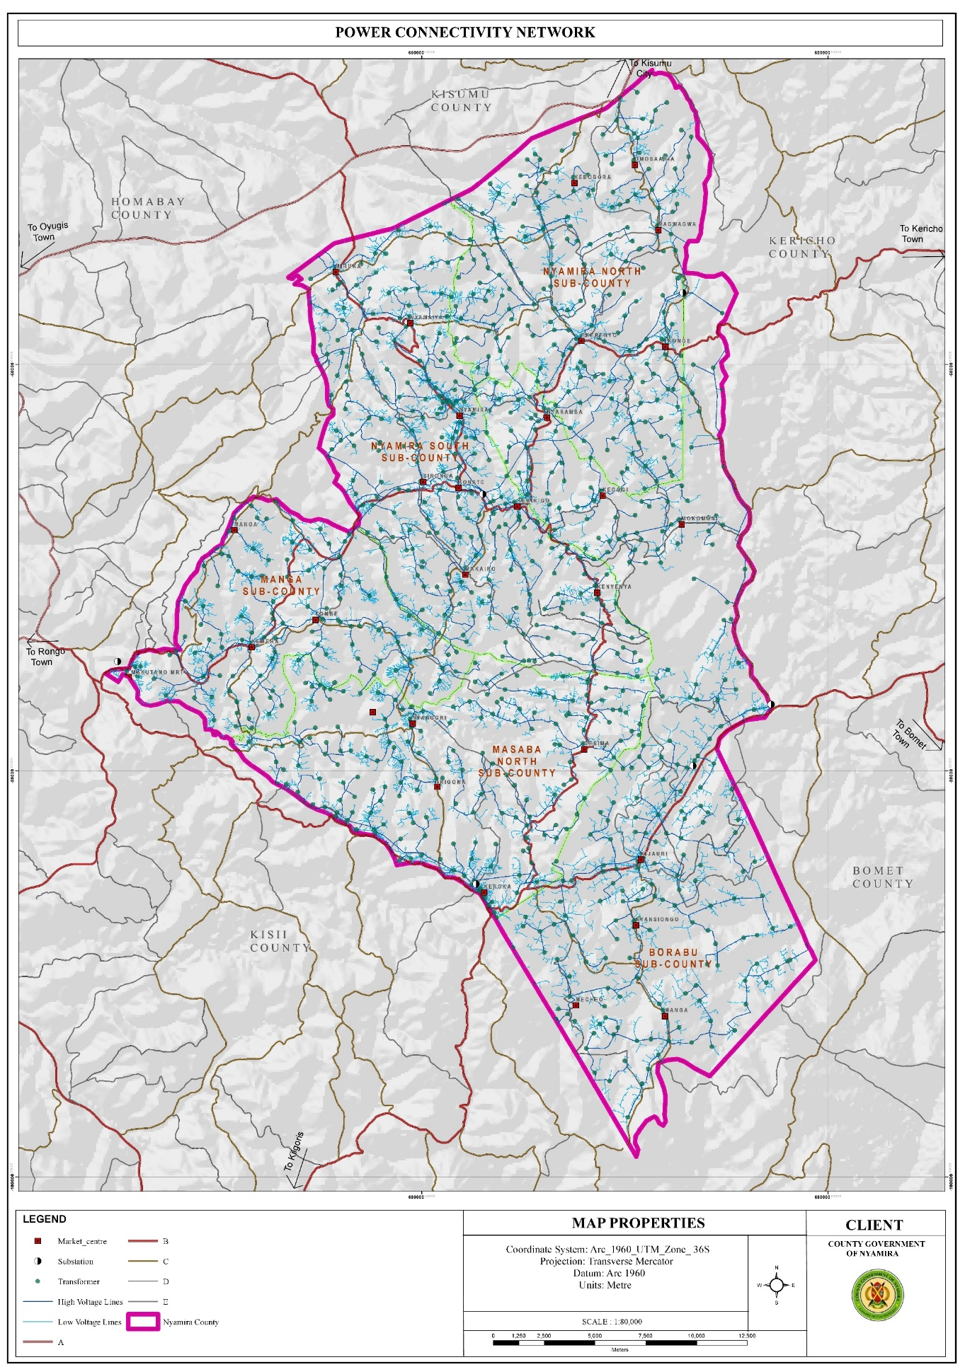

## 3.8 Water and Sanitation

### 3.8.1 Opportunities

1. Availability of water sources both surface and underground water sources : The county has about 2,021 shallow wells, 735 protected springs, 69 dams as well as over 2,790 unprotected springs and 7 permanent rivers. The availability of these water sources presents opportunities for easier access to water for both domestic and agricultural use.
2. High rainfall amounts present an opportunity for rain water harvesting The high rainfall patterns of between 1200 mm – 2100 mm per annum present an opportunity for rain water harvesting through creation of large-scale runoff collection reservoirs and household rainwater harvesting.
3. High water tables: The high-water tables in the county present opportunities for drilling of shallow wells. This explains the high number of shallow wells at the county which stands at 2,021. o Availability of waste The current solid waste generation in the county as at 2021 amounts to 104,146 tonnes and is projected to be 116,024 tonnes in 2030.

**Map 12: Water Sources**

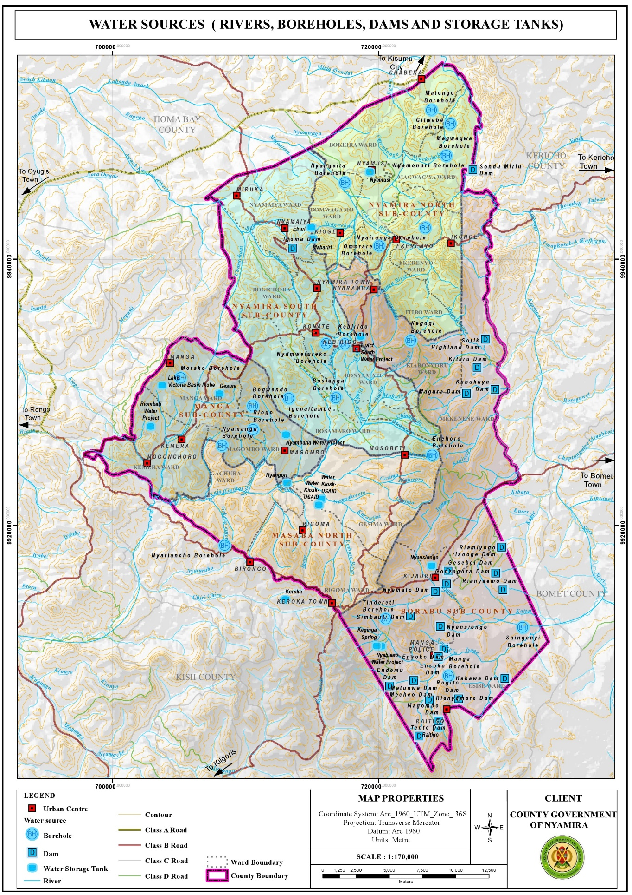

### 3.8.2 Challenges

1. Water: Over reliance on river and spring water Springs and rivers are the main water sources in the county, with about 36.6% using water from the streams/rivers while 36.4% and 9.4% utilize water from protected and unprotected springs respectively. o Inadequate water for the market facilities Water reticulation is only available in Nyamira and Keroka Towns. The rest of the towns rely on obtaining water from their natural sources.
2. Inaccessibility of water sources Despite the numerous water sources available in the county, water is not accessible to majority of the residents residing on the hilly areas as majority of the water sources are located at the low lands. The situation is further aggravated by the area’s topography which makes development of water reticulation from the low areas to the hilly areas unfeasible.
3. Poor water quality: The water quality in the county is compromised by constant pollution from the poor waste management practices carried out. Lack of designated solid waste management sites in most of the market centres has resulted to indiscriminate disposal of waste
4. Unprotected dams The unprotected dams are safety hazards to the county population as they are potential drowning areas. Siltation of some of the dams has made them dysfunctional over the years while privatization of others has made them inaccessible to the general public.
5. Rivers/springs : The rivers and springs are threatened by the planting of inappropriate tree species mainly eucalyptus trees. These tree species are a key contributing factor to the drying up of some streams and reduction of water levels in some rivers, wetlands and springs. o Lack of sewer reticulation network in the major urban centres Sewer reticulation is only available in Keroka Town. The rest of the urban centres don’t have a sewer reticulation network.

## 3.9 Education

* + 1. **Opportunities**

1. Have adequate schools : Based on the standards for the provision of educational facilities as outlined in the Physical Planning Handbook (2007), the existing educational facilities in the county are in surplus. This offers adequate learning institutions for the school going population. Presence of tertiary institutions The county has a total of 54 public TVETs spread across the county. The presence of tertiary facilities presents opportunities to further education as it offers alternatives to transition from secondary education to skill development. The student and staff population in these institutions provides a ready market for farm produce grown in the county and present opportunity for the construction of accommodation facilities.
   * 1. **Challenges**
2. Location of schools in the wetlands especially in Sironga making it difficult for infrastructure development
3. High number of pupils/students in boarding schools resulting to overstretched infrastructural facilities and services
4. Derelict infrastructural facilities in most of the public primary schools. o Poor waste management; solid waste is burnt in the open while inadequate land sizes constrain construction of additional pit latrines.
5. Poor accessibility of some of the schools within the rural areas due to impassable roads during the rainy season
6. Inadequate support infrastructure like appropriate sanitation facilities and learning materials o Delay in disbursement of funds to public schools affecting the smooth operation of school programs
7. High pupil/student teacher ratios in the public schools leading to overstretched teaching staff and poor performance of the pupils in national exams.
8. Inadequate land for the tertiary institutions as most of them are housed within primary or secondary schools land.
9. Inadequate schools for the physically challenged pupils forcing them to attend the normal schools without the prerequisite facilities for their learning.
10. Lack of water in some institutions making pupils carry water with jerricans to school. This practice is quite tiring to some of the pupils, thus affecting their concentration in class and their performance in general.

**Map 12: Distribution of Primary Schools**

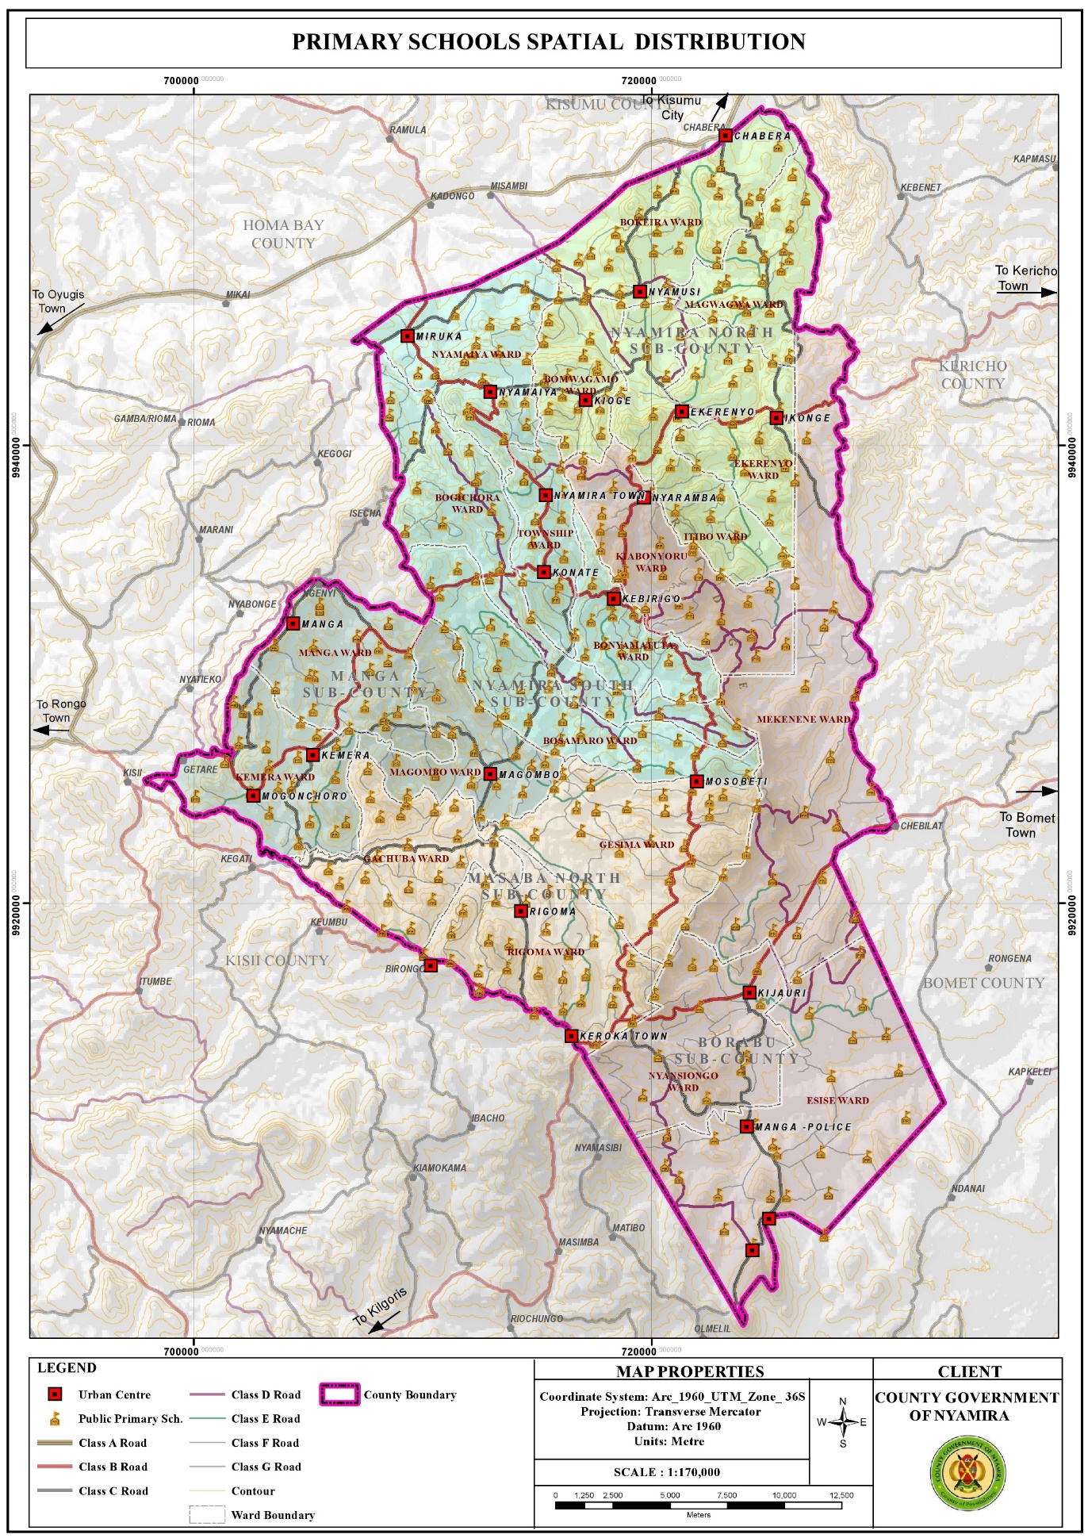

**Map 13: Distribution of Secondary Schools**

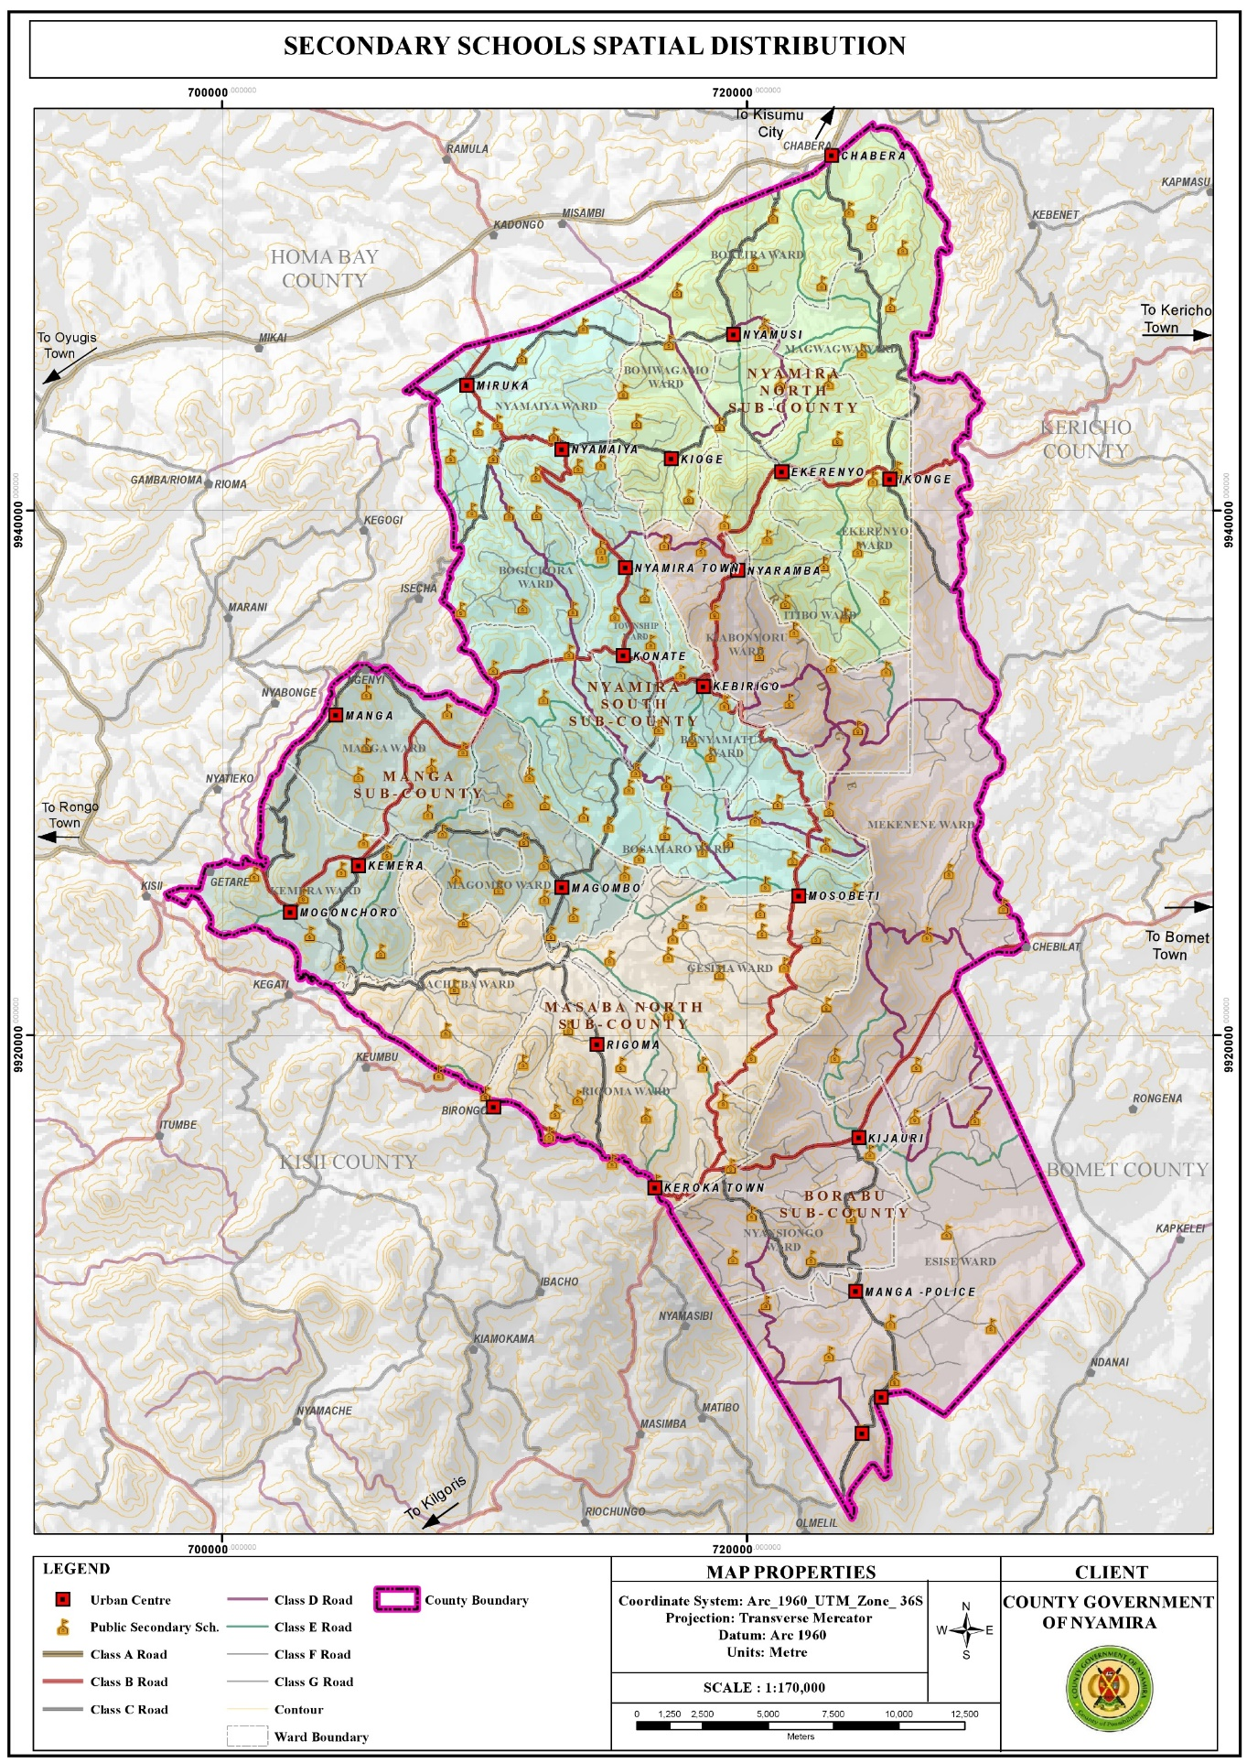

**Map 14: Distribution of Tertiary Institutions**



## 3.10 Health

**3.10.1 Opportunities**

1. Availability of county referral hospital Nyamira County Referral Hospital is a government health facility which provides comprehensive medical and surgical services. The presence of the facility within the county presents a good opportunity to the county residents to access high level medical services in close proximity.
2. Adequate health facilities Based on the standards given by the ministry of health with regard to provision of health facilities versus the catchment population, the county has adequate public health facilities. However, despite the over-provision of health facilities, private health facilities have been mushrooming. This could be attributed to the deplorable state of some of the public facilities and lack of the requisite equipments and drugs.

**3.10.2 Challenges**

1. Inadequate staffing leading to overstretched medical staff. The doctor: population ratio is 1:11,906 against the Kenyan ratio of 1 doctor per 10,000 people. This indicates overstretched medical personnel. The inadequacy in staffing leads to low motivation hence low productivity. o Poor accessibility of some health facilities located in the rural areas due to impassable roads during the rainy season.
2. Inadequate medical equipment, drugs and lack of specialized treatment in most public facilities leading to sprouting of private facilities.
3. Poor conditions of some of the health facilities, for instance some of the facilities are in derelict state rendering then dysfunctional.
4. Stalled projects; the construction of most of the proposed health facilities has stalled.
5. Mushrooming of private health facilities to fill in the niche as a result of poor services in the public health facilities.
6. Increased lifestyle diseases among the elderly for example high blood pressure, diabetes and arthritis hence the need for special facilities to help fight such illness.
7. Locational disadvantage of some of the health facilities like Ikonge dispensary which is located downhill making it inaccessible to majority of the residents due to the county’s rugged terrain.

**Map 15: Distribution of Health Facilities**

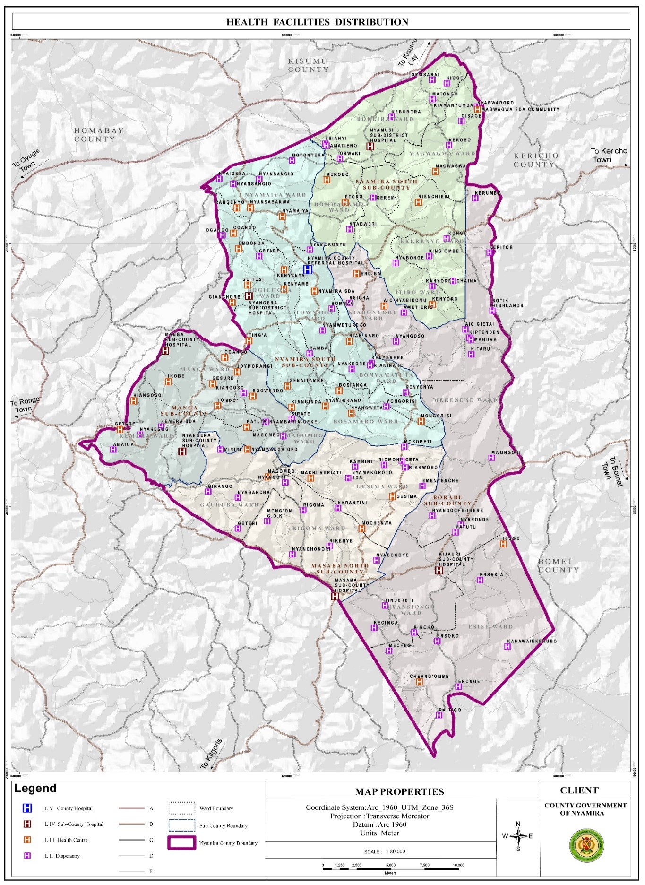

# CHAPTER 4

# DEVELOPMENT PRIORITIES, STRATEGIES AND PROGRAMMES

## 4.0 Introduction

This Chapter should provide sector development priorities, strategies, programmes, flagship projects, and cross-sectoral linkages.

## 4.1 Development Priorities and Strategies

The section includes the following:

**4.1.1 Sector Name:** **Health Services**

**Sector composition**: Sub sectors under the sector and their key roles.

1. Medical Services

Aims at ensuring improved service delivery.

1. Health Products and Technologies

Ensuring Improved commodity security in health facilities.

1. Promotive and Preventive Health Services

Responsible for making sure that there are no occurrences of disease and other health related problems. Also provides effective framework and Environment that support implementation of Health services

1. Health Administration, Policy planning, Monitoring and Evaluation and support services

Responsible for financial management and provision of policy guidance and leadership for the prudent use of resources and ensures that the core functions of the department are effectively and efficiently executed.

**Vision and Mission**

**Sector Vision**

A healthy and productive county with equitable access to quality health care.

**Sector Mission**

To provide quality health services for socio-economic development of the people of Nyamira County.

**Sector Goal(s)**: The section provide what the sector aims to achieve

* The department is also guided by the following Strategic Objectives:
* Provision essential health services
* Eliminate Communicable Conditions
* Minimize exposure to health risk factors
* Halt, and reverse rising burden on non- communicable conditions
* Improve Health infrastructure
* Foster collaborations for sustainable health service delivery
* Policy development, planning and research
* Sustainable health care financing for achievement of Universal Health Coverage

**Sector Priorities and Strategies:** The sector priorities are derived from the sector development issues documented in Chapters One and Two of the Plan. Strategies to achieve sector priorities should be proposed in relation to root causes of the development issues. Information in this section is presented in Table 4.

**Table 4 Sector Priorities and Strategies**

|  |  |
| --- | --- |
| **Programme 1: Medical Services** |  |
| **Sector Priorities** | **Strategies** |
| Increase health financing | * Digitalise billing system * Increase number of services provided * Lobby for increased departmental allocation from treasury * Advocate on the increase on registration on NHIF   Registration of indigents and funding of their NHIF premiums |
| Develop relevant policies and guidelines | * Customization of national guidelines and policies   Enact the Revolving Drug Fund act |
| Improve preventive maintenance | * Develop asset registers * Regular maintenance of vehicles, plant and medical equipment |
| Strengthen medicine and non –pharms supply chain | * Have in place commodity management system |
| Procure medical equipment as per norm and standard | * Progressively equip all health facilities to attain norms and standards |
| Digitalise health services | * Roll out a robust Health Management Information System |
| Develop research framework | * Institutionalize Research within the department |
| Improve staff welfare | * Develop and implement staff motivation framework |
| Improve skills mix | * Training through on job and in service |
| Increase staffing | * Recruitment of additional missing staff |
| Avail specialized services. | Completion of doctors plaza |
| Adequately layout facilities | Follow norms and standards to construct health facilities  Strengthen collaboration with Public works |
| Provide essential health services | Conduct survey on causes of high maternal and neonatal deaths. |
| Strengthen community health systems | Provide incentives to Community Health workers |
| Develop health facilities master plan | Facilitate health facilities to develop master plans |
| Develop collaboration framework with health-related sectors | Hold stakeholders meeting  Establish call centre |
| Minimize exposure to health risk factors | Community health Education  Set up IPC committees in all facilities  AYSRH activities |
| **Programme 2:Preventive Health Services** |  |
| Strengthen provision of public health services | Carry out inspections of eateries and health facilities  Carry out food sampling in markets  Enforce public health laws |
| Reduce the burden of non communicable diseases and malnutrition | Develop a cancer centre at NCRH  Early screening and detection of NCDs |
| Eliminate communicable diseases | Health promotion |
| Reduce the burden of Violence & Injuries | Capacity build staff on emergency response  Create emergency response teams in all facilities  Community sensitization  Form a multi-sectoral TWGs  Construction of Accident and emergency centre at NCRH  Construction of GBVRC at NCRH |

## 4.2 Sector Programmes and Flagship Projects

This section should provide sector programmes and flagship projects to be implemented within the planned period as presented in tables 5 and 6 respectively.

### 4.2.1 Sector Programmes

The section should provide sector programmes to be implemented within the planned period. This information should be presented in a tabular form.

**Table 5 Sector Programmes**

|  |  |  |  |  |  |  |  |  |
| --- | --- | --- | --- | --- | --- | --- | --- | --- |
| **Programme** | **Delivery Unit** | **Key Outputs** | **Key Performance Indicators** | **Linkage to SDGs** | **5 years** | | **5 years** | |
| **Target** | **Cost** | **Target** | **Cost** |
| **Ksh** | **Ksh** |
| **PROGRAM 1:MEDICAL SERVICES** | | | | |  | | | |
| **Outcome: Improved service delivery** | | | | | | | | |
| **SP 1.1 Health infrastructure** |  | Completion of Doctors Plaza/Amenity wards | Percentage of completion |  | 100% | 24,024,112 | 100% | 0 |
| Completion of Nyamira eye hospital at Nyamwetureko | Percentage of completion |  | 100% | 10,172,004 | 100% | 0 |
|  | Completion of 0PD and Inpatient at Ekerenyo | Percentage of completion |  | 100% | 18,262,622 | 100% | 0 |
|  | Completion of Inpatient wards at Manga Hospital | Percentage of completion |  | 100% | 16,766,578 | 100% | 0 |
|  | Completion Inpatient wards and theater at Magwagwa | Percentage of completion |  | 100% | 980,455 | 100% | 0 |
|  | Completion in patient wards at Nyamusi Hospital | Percentage of completion |  | 100% | 6,828,315 | 100% | 0 |
|  | Completion of twin staff house at motagara | Percentage of completion |  | 100% | 3,990,155 | 100% | 0 |
|  | Completion of twin staff house at emenyenche health facility | Percentage of completion |  | 100% | 1,720,610 | 100% | 0 |
|  | Completion of OPD at Kenyamware | Percentage of completion |  | 100% | 1,337,914 | 100% | 0 |
|  | Completion of Twin staff house at Nyakeore | Percentage of completion |  | 100% | 1,546,676 | 100% | 0 |
|  | Completion of twin Staff house at kahawa | Percentage of completion |  | 100% | 1,715,205 | 100% | 0 |
|  | Completion of OPD at Nyaobe | Percentage of completion |  | 100% | 1,775,582 | 100% | 0 |
|  | Completion of twin staff house nyanchonoria | Percentage of completion |  | 100% | 1,556,597 | 100% | 0 |
|  | Completion of twin staff house at chaina | Percentage of completion |  | 100% | 3,505,363 | 100% | 0 |
|  | Completion of 300 bed capacity isolation block at nyamira hospital | Percentage of completion |  | 100% | 49,239,516 | 100% | 0 |
|  | Proposed Renovation and installation of new cooling system at NCRH Mortuary | Percentage of completion |  | 100% | 9,040,205 | 100% | 0 |
|  | proposed renovation of NCRH Laboratory | Percentage of completion |  | 100% | 5,450,509 | 100% | 0 |
|  | Completion of maternity at isoge health facility | Percentage of completion |  | 100% | 1,499,601 | 100% | 0 |
|  | Completion of maternity block at Nyankono Health Centre | Percentage of completion |  | 100% | 3,499,310 | 100% | 0 |
|  |  | Isolation complex |  |  | 2 | 95,000,000 | 100% | 0 |
|  |  | Ekerenyo OPD block |  |  | 2 | 35,000,000 | 100% | 0 |
|  |  | Kiangoso staff house |  |  | 1 | 12,000,000 | 100% | 0 |
| **S.P 1.1 Total** |  |  |  |  |  | 304,911,329 |  | 0 |
| **S.P 1.2 Emergency and Referral Services** |  | Ambulance procured | No. of ambulance procured | **SDG 3** | 2 | 16,000,000 | 80% | 16,000,000 |
|  | Hospitals with Accident and Emergency Centres | No of hospitals with Accident and Emergency Centres | 2 | 35,000,000 | 80% | 35,000,000 |
| **SP 1.2 Total** |  |  |  |  |  | 51,000,000 |  | 51,000,000 |
| **S.P.1.3 Hospital Specialized Services** |  | Establish functional radiology unit at Kijauri | functional radiology unit established | **SDG 3 & 13** | 2 | 18,000,000 | 100% | 18,000,000 |
|  | Establish Ophthalmic Unit at Ekerenyo SCH | Functional Ophthalmic Unit established | 3 | 18,000,000 | 100% | 18,000,000 |
|  | Establish functional Urology unit at NCRH | functional urology unit at NCRH established | 1 | 5,000,000 | 100% | 5,000,000 |
|  | Modernize lad at Borabu SCH |  | 1 | 10,000,000 | 100% | 10,000,000 |
|  | Modernize lad at Ekerenyo SCH | Modern, Equipped lab | 1 | 6,000,000 | 100% | 6,000,000 |
|  | Construction of mother child hospital |  | 2 | 121,000,000 | 100% | 121,000,000 |
|  | Construction of level 4 hospital at Ekerubo Gietai |  | 5 | 100,000,000 | 100% | 100,000,000 |
|  | Upgrade of NCRH to level 5 |  | 2 | 50,000,000 | 100% | 50,000,000 |
|  | Construction of modern funeral funeral home |  | 2 | 30,000,000 | 100% | 30,000,000 |
|  | Construction of incinerators | No of incinirators constructed | 2 | 12,000,000 |  | 12,000,000 |
|  | Hopitals renovated | No of hospitals renovated | 6 | 15,000,000 | 80% | 15,000,000 |
|  | Accrediting hospitals to be baby friendly | No of hospitals accredited to be baby friendly | 2 | 2,000,000 | 50% | 2,000,000 |
|  | Establish 2 staff breast feeding centres | No of breast feeding centres | 2 | 6,000,000 | 100% | 6,000,000 |
|  | Operation theatre constrcuted | No of theatre constructed | 3 | 50,000,000 | 95% | 50,000,000 |
|  | Construct and equip a Kitchen at Keroka SCH | functional Kitchen at Keroka established | 1 | 10,000,000 | 100% | 10,000,000 |
| **SP 1.3 Total** |  |  |  |  |  | **453,000,000** |  | **453,000,000** |
| **SP 1.4 Hospital Nutrition Services** |  | Food and rations | No of hospitals supplied with adequate food and rations | **SDG 2 & 3** | 0 | 70,000,000 | 0% | 70,000,000 |
| **SP 1. 4 Total** |  |  |  |  |  | **70,000,000** |  | **70,000,000** |
| **Total requirement Programme 1** | | | | |  | **878,911,329** |  | **878,911,329** |
| **PROGRAM 2: HEALTH PRODUCTS AND TECHNOLOGIES** | | | | |  |  |  |  |
| **Outcome: Improved commodity security in health facilities** | | | | |  |  |  |  |
| **S.P 2.1 Pharmaceuticals and non pharmaceuticals** |  | Facilities stocked with essential medicines and medical supplies (EMMS) annually | Proportion of days facilities were stocked with EMMS annually | **SDG 3&9** | 4.8 | 850,000,000 | 80% | 850,000,000 |
|  | Pharmaceutical production and innovation unit Phase 1 | Pharmaceutical production and innovation unit civil works done | 3 | 50,000,000 | 80% | 50,000,000 |
| **S.P 2.1 Total** |  |  |  |  | **900,000,000** |  | **900,000,000** |
| **S.P 2.2  Medical equipment and technologies** |  | Improve preventive maintenance on plant and medical equipment | Medical equipment maintained | 1 | 95,000,000 | 100% | 95,000,000 |
| 0 |  | 0 |
|  | Revolving drug fund | No of revolving drug fund established | 1 | 20,000,000 | 100% | 20,000,000 |
|  | Renovation of county drug store | No of county drug store renovated | 1 | 5,000,000 | 100% | 5,000,000 |
|  | Installation of integrated logistics MIS | No of integrated logistics MIS installed | 2 | 7,500,000 | 100% | 7,500,000 |
|  | Procure medical equipment as per norm and standard for primary health facilities | Medical equipment procured | 1 | 75,000,000 | 100% | 75,000,000 |
|  | Equipping of 80 bed amenity at county referral hospital | No. of 80 bed amenity equipped at county referral hospital | 0.5 | 30,000,000 | 50% | 30,000,000 |
| **S.P 2.2 Total** |  |  |  |  |  | **232,500,000** |  | **232,500,000** |
| **Total requirement for Programme 2** | | | | |  | **1,132,500,000** |  | **1,132,500,000** |
| **PROGRAMME 3. PROMOTIVE AND PREVENTIVE HEALTH SERVICES** | | | | |  |  |  |  |
| **Outcome: To Reduce Incidence Of Preventable Diseases And Mortality In The County** | | | | |  |  |  |  |
| **S.P. 3.1: Rehabilitation of Primary Health Care Infrastructure** |  | Repair of burning chambers in selected 10 facilities | No of burning chambers constructed | **SDG 3&6** | 20 | 4,000,000 | 90% | 4,000,000 |
|  | Construction of Pit latrines in 10No. primary facilities | No of Pit latrines constructed in primary facilities | 20 | 10,000,000 | 80% | 10,000,000 |
|  | Renovate and establish laboratory rooms in primary facilities currently not offering lab services | No. of laboratories renovated in primary facilities | 4 | 10,000,000 | 80% | 10,000,000 |
| **S.P 3.1 Total** |  |  |  |  | **24,000,000** | 0% | **24,000,000** |
| **SP. 3.2 Communicable Disease control services** |  | HIV/STI control |  | 0 | 5,000,000 | 0% | 5,000,000 |
|  | Malaria control activities |  | 0 | 5,000,000 | 0% | 5,000,000 |
|  | TB control Services |  | 0 | 5,000,000 | 0% | 5,000,000 |
| **S.P 3.2Total** |  |  |  |  | **15,000,000** |  | **15,000,000** |
| **SP3.3. Non Communicable Disease control** |  | Diabetes and hypertension screening services |  | 0 | 5,000,000 | 0% | 5,000,000 |
|  | Cancer screening activities |  | 0 | 15,000,000 | 0% | 15,000,000 |
| **S.P 3.3 Total** |  |  |  |  | **20,000,000** |  | **20,000,000** |
| **SP3.4 Environmental health services** |  | Hygiene and sanitation | No. of water tanks installed and handwashing facilities | 0 | 6,000,000 | 0% | 6,000,000 |
|  | Disease surveillance activities |  | 0 | 3,500,000 | 0% | 3,500,000 |
| **S.P 3.4 Total** |  |  |  |  | **9,500,000** |  | **9,500,000** |
| **SP 3.5 Reproductive,Maternal, Neonatal, Child and Adolescent Health Services** |  | Family Planning |  | 0 | 30,000,000 | 0% | 30,000,000 |
|  | Immunization activities |  | 0 | 35,000,000 | 0% | 35,000,000 |
|  | Scaling up skilled care deliveries |  | 0 | 5,000,000 | 0% | 5,000,000 |
|  | Constrction of staff house in HF | No of staff houses constrcued | 21 | 63,000,000 | 70% | 63,000,000 |
|  | Maternity units operational | No of maternity units operational | 9 | 27,000,000 | 90% | 27,000,000 |
|  | Procurement of vaccine fridges | No of vaccine fridges procured | 14 | 7,000,000 | 70% | 7,000,000 |
|  | Youth friendly centers set up | No of youth friendly centers set up | 3 | 50,000,000 | 30% | 50,000,000 |
|  | Adolescent and youth Sexual Reproductive Health |  | 0 | 13,000,000 | 0% | 13,000,000 |
| **S.P 3.5 Total** |  |  |  |  |  | **230,000,000** |  | **230,000,000** |
| **Total requirement for Programme 3** | | | | |  | **298,500,000** |  | **298,500,000** |
| **PROGRAMME 4:**  **HEALTH ADMINISTRATION, POLICY, PLANING, MONITORING AND EVALUATION AND SUPPORT SERVICES** | | | | |  |  |  |  |
| **SP4.1 General administration and support services** |  | Inclusivity and absorption of undefined cadres in the existing workforce(mother mentors,peer educators,hts counselors,sample collectors and CHVs) |  |  | 0 | 610,510,000 | 0% | 610,510,000 |
|  | ICT equipment procured(laptops,computers and accessories) |  | 15 | 1,500,000 | 80% | 1,500,000 |
|  | Employment of Health care workers |  | 30 | 30,000,000 | 100% | 30,000,000 |
|  | Payment of casual wages at Primary health level |  | 0 | 109,891,800 | 0% | 109,891,800 |
| **S.P 4.1 Total** |  |  |  |  | **751,901,800** | **0%** | **751,901,800** |
| **S.P. 4.2: Health policy and planning, Monitoring and evaluation** |  | Nyamira Health Sector Plan | No. of Nyamira Health Sector Plan | 5 | 5,000,000 | 100% | 5,000,000 |
|  | County programs Strategic Plan(HIV, Community Health, Nutrition, M&E, HIS ) developed | No. of County programs Strategic Plan(HIV, Community Health, Nutrition, M&E, HIS ) developed | 5 | 5,000,000 | 100% | 5,000,000 |
|  | Environmental Health Policy and Bill enacted | No. of Environmental Health Policy and Bill enacted | 1 | 5,000,000 | 100% | 5,000,000 |
|  | One County Health Investment and Strategic Plan (CHSSP) developed | No. of One County Health Investment and Strategic Plan (CHSSP) developed | 1 | 5,000,000 | 100% | 5,000,000 |
|  | County Pharmaceutical Policy and Bill enacted | No. of County Pharmaceutical Policy and Bill enacted | 1 | 5,000,000 | 100% | 5,000,000 |
|  | Maternal and Child health Policy and Bill | No. of Maternal and Child health Policy and Bill | 1 | 5,000,000 | 100% | 5,000,000 |
|  | HRH strategic plan | No. of HRH strategy implemented | 1 | 14,000,000 | 100% | 14,000,000 |
|  | Health Sector Report developed | No. of Health Sector Report developed | 5 | 2,500,000 | 100% | 2,500,000 |
|  | APR developed | No. of APR developed | 5 | 1,000,000 | 100% | 1,000,000 |
|  | Projects monitoring and Evaluation | No. of Projects monitoring and Evaluation reports developed | 5 | 3,250,000 | 100% | 3,250,000 |
|  | Preparation of Health Department Budget | Health budget developed | 5 | 3,900,000 | 100% | 3,900,000 |
|  | Inventory Management | No. of inventory Managements done | 5 | 1,000,000 | 500% | 1,000,000 |
|  | Supportive supervision activities | Supervision reports made | 5 | 250,000 | 100% | 250,000 |
|  | Performance reviews | No of performance review meeting held | 5 | 5,000,000 | 100% | 5,000,000 |
|  | Data Quality Audits | No. of DQAa done | 15 | 3,000,000 | 80% | 3,000,000 |
|  | FIF scale up activities |  | 10 | 3,000,000 | 1000% | 3,000,000 |
| **S.P 4.2 Total** | | | | |  | **66,900,000** |  | **66,900,000** |
| **Total requirement for Programme 4** | | | | |  | **818,801,800** |  | **818,801,800** |
| **Total requirement for the Health Services (All Programmes)** | | | | |  | **3,128,713,129** |  | **3,128,713,129** |

* *Refer to the 169 SDGs Targets (*[*https://sdgs.planning.go.ke/)*](https://sdgs.planning.go.ke/)

### 4.2.2 Flagship Projects

The section should summarize all known county flagship projects for implementation by both levels of Government and Development Partners in the county. The information should be presented in Table 6.

**Table 6 Flagship Projects**

### 

|  |  |  |  |  |  |  |  |  |
| --- | --- | --- | --- | --- | --- | --- | --- | --- |
| **Project**  **Name** | **Location** | **Objective** | **Description of Key Activities** | **Key**  **Output(s)** | **Time Frame\*** | **Estimated cost (KSh.)** | **Source of Funds** | **Lead Agency** |
| Mother child hospital | NCRH | To reduce maternal and neonatal deaths | Designs  Tendering  Construction  Equiping  Commissioning | Architectural and structural designs  Successful bidder  MC HF  Medical equipment | 3months  2month  3year  1year | 240,000  760,000  100M  20M  ……….  121M | CGN | Health |
|  |  |  |  |  |  |  |  |  |
| Modern Funeral Home | NCRH |  | Designs  Tendering  Construction  Equiping  Commissioning | Architectural and structural designs  Successful bidder  Modern funeral Home  Funeral Home Chapel-1M  Mortuary cold chain-15M  Mortuary furniture-5M  Waiting bay furniture-2M  Hearse-4M | 3months  2month  3year  1year | 240,000  760,000  50M  ………. |  |  |
| Accident and emergency center | NCRH |  | Designs  Tendering  Construction  Equiping  Commissioning | Architectural and structural designs  Successful bidder  MC HF  Medical equipment | 3 months  2month  3year  1year | 240,000  760,000  34M |  |  |

***\*Give time frame in years, i.e., the start and end year of the project implementation period.***

*Refer to the National Treasury Circular No. 1/2022 (Kenya Vision 2030 flagship programmes/projects identification criteria).*

Note: The programmes and projects mainstream cross-cutting issues such as green growth and green economy, climate change, HIV and AIDS, Gender, Youth, Persons with Disability (PWD), and Disaster Risks among others.

## 4.3 CIDP Linkages with National Development Agenda, Regional and International

## Development Frameworks

This section indicates how the CIDP is linked with and is contributing towards the achievement of the following (among others):

1. Kenya Vision 2030 and its Medium Term Plans;
2. The UN 2030 Agenda and the Sustainable Development Goals;
3. Africa’s Agenda 2063;
4. Paris Agreement on Climate Change, 2015;
5. EAC Vision 2050;
6. ICPD25 Kenya Commitments; and
7. Sendai Framework for Disaster Risk Reduction 2015 – 2030.

This information is presented in Table 7.

**Table 7 Linkage with Kenya Vision 2030, other plans and international obligations**

|  |  |  |
| --- | --- | --- |
| **National Development**  **Agenda/Regional/International Obligations** | **Aspirations/Goals**  **(Frameworks goal)** | **County Government contributions/Interventions\***  **(Programme strategies)** |
| *ICPD25 KENYA COMMITTMENTS* | *Commitment no.3*  *Progressively increase health sector financing to 15% of total budget as per the Abuja declaration by 2030.* | * Digitalise billing system * Increase number of services provided * Lobby for increased departmental allocation from treasury * Advocate on the increase on registration on NHIF * Registration of indigents and funding of their NHIF premiums |
| *KENYA’S DEMOGRAPHIC DIVIDEND ROADMAP(2020-2030)* | *Foster sustainable investments in health systems, including in human resources and infrastructure, with the goal of enhancing access to quality health services for all.*  *Key action9(d)*  *Employ more human resource for health* | * Recruitment of additional missing staff |
| *AGENDA 2063* | *Goal 3*  *Healthy and well-nourished citizens* | Conduct survey on causes of high maternal and neonatal deaths. |
| *ICPD25 KENYA COMMITMENTS* | ***Commitment no.13***  *End FGM by strengthening coordination in the area of legislation and policy framework, communication and advocacy, evidence generation and support cross border collaboration on elimination of FGM by 2022.*  *Commitment no.14*  *Eliminate by 2030,all forms of GBV including child and forced marriages by addressing social and cultural norms that propagate the practice while providing support to women and girls who have been affected*   * *Increased access to quality and comprehensive response and support services across sectors* * *Improve coordination and sustainability for effective programming for GBV prevention and response.* * *Eliminate social cultural norms that affect women and girls* | Capacity build staff on emergency response  Create emergency response teams in all facilities  Community sensitization  Form a multi-sectorial TWGs  Construction of Accident and emergency centre at NCRH   * Construction of FGM and GBVRC at NCRH |

*\*This should be presented either as priorities and/or strategies.*

## 4.4 Cross-Sectoral Linkages

This section provides the cross-sectoral impacts of each sectoral programme and appropriate actions to harness cross-sector synergies or mitigate adverse cross-sector impacts.

* **Harnessing cross-sector synergies:** Indicate what considerations will be made in respect to harnessing cross-sector synergies arising from possible programme impacts.
* **Mitigating adverse cross-sector impacts:** State the mitigation measures that may be adopted to avoid or manage potential adverse cross-sector impacts.

The cross-sectoral impacts and the mitigation measures should be presented in the format indicated in Table 8.

**Table 8 Cross-sectoral impacts**

|  |  |  |  |  |
| --- | --- | --- | --- | --- |
| **Programme Name** | **Linked**  **Sector(s)** | **Cross-sector Impact** | | **Measures to Harness or Mitigate the Impact** |
| **Synergies\*** | **Adverse impact** |
| P1:Medical Services | Roads | Physical access to health services | Pulling down of structures on road reserve | Develop a resettlement plan.  Proper county plan to guide construction. |
| P1:Medical Services | Environment and water | Prevention of water borne diseases | Environment pollution | Comply and enforce NEMA guidelines |
| P3:Promotive and Preventive | Education | Improved maternal and child health  Reduced teen pregnancies | High mortality rates  Teen pregnancies | Creating of youth friendly centers. |
| P2:Health Products and Technologies | Roads | Easy transport for the health products. | Pulling down of structures on road reserve | Develop a resettlement plan.  Proper county plan to guide construction. |
| P3:Promotive and Preventive | Agriculture, Livestock and Fisheries | Food security and good nutrition |  |  |
| P4:Health Administration and Support services | Finance and Accounting | Timely financing to health department. |  |  |

*\*Synergies – areas of collaboration between sectors for greater impact*

# 

# CHAPTER FIVE

# SECTOR IMPLEMENTATION FRAMEWORK

## 5.1. Overview

This chapter provides the county’s institutional arrangement and their specific roles towards implementation of the CIDP. In addition, the chapter presents the resource mobilization and management framework, asset management, and risk and mitigation measures.

## 5.2. Institutional Framework

This section provides the institutional framework of the County including an organizational chart that displays the implementation the CIDP and how the County’s internal transformation needs are addressed. The framework indicates the County Government’s institutional arrangements and demonstrate linkages with the National Government Departments at the county as well as other key stakeholders.

**Figure 3: Health Organogram**

The section indicates the specific roles of the key institutions towards implementation of the CIDP as in Table 9.

**Table 9 Stakeholders**

|  |  |  |
| --- | --- | --- |
| **S/No**. | **Stakeholders** | **Role in Implementation of the CIDP** |
| 1. | County Executive Committee | Policy formulation and implementation of sector plans. |
| 2. | County Assembly | Legislation and oversight of projects and their implementation. |
| 3. | County Government Departments | Executives of various functions are mandated under schedule 4 of COK 2010 |
| 4. | County Planning Unit | Budgeting, planning and implementing programs and budgets. |
| 5. | Office of the County  Commissioner | Co-ordination of the national government functions at the county level. |
| 6. | National Planning Office at the county |  |
| 7. | Other National Government Departments and Agencies at the county | A link to the national government to ensure both the county and national government agenda are aligned towards . |
| 8. | Development Partners | Entering into PPP to ensure achievement of development. |
| 9. | Civil Society Organizations | Whistle blowers and educating the public. |
| 10. | Private Sector | Complementing the county government and addressing dynamics. |

## 5.3 Resource Mobilization and Management Framework

This section provides the projected resource requirements by sector, revenue projections, estimated resource gap and measures of addressing the gaps.

### 5.3.1 Resource Requirements by Sector

This section indicates the projected financial resources required for each sector during the plan period. The section includes the percentage of the total budget for each sector. This information is presented as in Table 10.

**Table 10 Summary of Sector Financial Resource Requirements**

|  |  |  |  |  |  |  |  |
| --- | --- | --- | --- | --- | --- | --- | --- |
| **Health** | **FY** | **FY** | **FY** | **FY** | **FY** | **Total** | **% of total budget requirements** |
| **2023/24** | **2024/25** | **2025/26** | **2026/27** | **2027/28** |
| **P1- Medical services** | 109,000,000 | 10,700,000 | 75,000,000 | 88,500,000 | 44,000,000 | 424,000,000 | 22.0615016 |
| **P2-Health products and technologies** | 205,000,000 | 245,000,000 | 242,500,000 | 215,000,000 | 225,000,000 | 1,132,500,000 | 58.9260628 |
| **P3-Promotive and preventive health services** | 60,200,000 | 71,700,000 | 52,700,000 | 66,200,000 | 47,700,000 | 298,500,000 | 15.5315053 |
| **P4-Health administration,policy,planning,M&E and support services** | 43,550,000 | 5,550,000 | 6,600,000 | 5,600,000 | 5,600,000 | 66,900,000 | 3.48093033 |
| **Sector total** | **417,750,000** | **332,950,000** | **376,800,000** | **375,300,000** | **322,300,000** | **1,921,900,000** | **100** |

### Source: Sectors

#### *\*1-2% of the total CIDP budget should be allocated to County Climate Change Fund to enhance county resilience* *and mitigation to climate change (Climate Change Act, 2016)*

### 5.3.2: Revenue Projections

This section indicates the various sources of revenue in the County as in Table 11.

**Table 11 Revenue Projections**

|  |  |  |  |  |  |  |  |
| --- | --- | --- | --- | --- | --- | --- | --- |
| **Type of Revenue** | **Base year 2022/23** | **FY** | **FY** | **FY** | **FY** | **FY** | **Total** |
| 2023/24 | 2024/25 | 2025/26 | 2026/27 | 2027/28 |
| a) Equitable share | 1,680,834,021 | 1,848,917,423 | 2,033,809,165 | 2,237,190,082 | 2,460,909,090 | 2,706,999,999 | 11,287,825,760 |
| b) Conditional grants FIF (GOK) | 155,000,000 | 170,500,000 | 187,550,000 | 206,305,000 | 226,935,500 | 249,629,050 | 1,040,919,550 |
| c) Conditional Grants | 7,106,000 | 7,816,600 | 8,598,260 | 9,458,086 | 10,403,895 | 11,444,284 | 47,721,125 |
| (Development Partners) | - | - | - | - | - | - | - |
| e) Conditional allocations from loans and grants (GoK) | - | - | - | - | - | - | - |
| f) Conditional allocations from loans and grants (Development Partners) | - | - | - | - | - | - | - |
| g) Own Source Revenue | - | - | - | - | - | - | - |
| h) Public Private Partnership (PPP) | - | - | - | - | - | - | - |
| g) Other sources (Specify) | - | - | - | - | - | - | - |
| **Total** | **1,842,940,021** | **2,027,234,023** | **2,229,957,425** | **2,452,953,168** | **2,698,248,485** | **2,968,073,333** | **12,376,466,434** |

### 5.3.3 Estimated Resource Gap

This section highlights the County resource gap in terms of the estimated resource needs against the projected revenues as in Table 12.

**Table 12 Resource Gaps**

|  |  |  |  |
| --- | --- | --- | --- |
| **FY** | **Requirement (Ksh.)** | **Estimated Revenue(Ksh.)** | **Variance (Ksh.)** |
| **2023/24** | 996,540,000 | 2,027,234,023 | (1,030,694,023) |
| **2024/25** | 1,304,540,000 | 2,229,957,425 | (925,417,425) |
| **2025/26** | 1,024,840,000 | 2,452,953,168 | (1,428,113,168) |
| **2026/27** | 846,540,000 | 2,698,248,484 | (1,851,708,484) |
| **2027/28** | 707,040,000 | 2,968,073,333 | (2,261,033,333) |
| **Total** | **4,879,500,000** | **12,376,466,432** | **(7,496,966,432)** |

### 5.3.4 Resource Mobilization and Management Strategies

This section identifies the feasible resource mobilization and management strategies to address the resource gap. The section includes capital financing strategies, operational financing strategies and other strategies that will enhance cost effectiveness.

## 5.4 Asset Management

The section discusses the measures the County Government has put in place to manage its assets.

## 5.5 Risk Management

This section provides the key anticipated risks that may hinder the implementation of the CIDP, potential risk implications and proposed mitigation measures to enhance sustainable development. The information is provided in the format presented in Table 13.

**Table 13 Risk, Implication, Level and Mitigation Measures**

|  |  |  |  |  |
| --- | --- | --- | --- | --- |
| **Risk Category** | **Risk** | **Risk Implication** | **Risk Level (Low, Medium, High)** | **Mitigation measures** |
| Financial | Inadequate financial resources | Stalled projects | Medium | Resource mobilization  Strategies |
| Technological | Cyber security  Risk | Breach of valuable information | High | Investment in cyber security risk management |
| Climate Change | Drought | Malnutrition and poor health standards. | High | Climate smart agriculture practices |
| Organizational | Inadequate  Human Resource Capacity | Inefficiency in  service delivery | Medium | Timely recruitment |

# 

# CHAPTER SIX

# MONITORING, EVALUATION AND LEARNING

## 6.1 Overview

This chapter outlines how the plan will be monitored and evaluated during and after its implementation. The M&E processes, methods and tools should be guided by Section 232 of the Constitution and all the legal provisions that provide for M&E, County M&E Policy in line with the National M&E Policy, CIMES Guidelines, Kenya Norms and Standards for M&E and Kenya Evaluation Guidelines. The chapter highlights: The proposed M&E structure; data collection, analysis, reporting and learning; M&E outcome indicators tracking; and dissemination and feedback mechanism.

## 6.2 County Monitoring and Evaluation Structure

This section summarizes systems and structures put in place in the County to organize the M&E process for implementing the plan. This includes the institutional arrangement of the M&E function (Directorate/Unit), various committees and coordination of M&E activities i.e. departmental focal persons, champions and stakeholder engagement as stipulated in the CIMES guidelines.

## 6.3 M&E Capacity

This section discusses M&E skills available, the resources allocated for M&E function and technological requirements for implementing the M&E function.

## 6.4 M&E Outcome Indicators

This section presents programme outcome indicators by sector as captured in Table 17 on sector programmes in Chapter Four. The information is presented as in Table 14.

**Table 14 Outcome Indicator Reporting**

|  |  |  |  |  |  |  |  |
| --- | --- | --- | --- | --- | --- | --- | --- |
| **Programme** | **Outcome** | **Outcome**  **Indicator (s)** | **Baseline\*** | | **Mid**  **Term**  **Target** | **End**  **Term**  **Target** | **Reporting**  **Responsibility** |
| **Value** | **Year** |
| General administration, policy planning,M&E and support services | Efficient and effective customer satisfaction in public service delivery to the citizen of the county and health policy formulation | Proportion of satisfied customers in public service delivery. |  |  |  |  | Director GA |
| Health Products and Technologies. | Improved commodity security in health facilities. | Proportion of commodity security in health facilities. |  |  |  |  | Director health products and technologies |
| Medical Services | Reduced maternal and child mortality rate | Proportion of maternal and child mortality rate |  |  |  |  | Director medical services |
| Promotive and Preventive Health Services | Reduce incidence of preventable diseases and mortality in the county. | Proportion of preventable diseases and mortality in the county |  |  |  |  | Director Preventive health services |

***\*Use most recent reliable statistics***

## 6.5 Data Collection, Analysis and Reporting

This section provides the main methods and tools that will be used for data collection, archiving, analysis and reporting arrangements in line with the National M&E Norms and Standards. This includes development of CIDP Indicator Handbook, standard reporting templates based on the County Annual Progress Report Guidelines. The County Government should also state how they integrate technology in M&E through the use of e-CIMES. The section should also provide the types of M&E Reports to be prepared and the frequency of reporting.

## 6.6 Dissemination, Feedback Mechanism, Citizen Engagement and Learning

This section highlights how the County Government will disseminate, get feedback, engage citizens in M&E process as well as learning. Specific means of communicating M&E information based on unique needs of various stakeholders should be identified. The section should also present how M&E reports produced should be used for evidence-based decision making (*State of the County Address, peer to peer learning, presentation of the reports to Budget committees among others*).

## 6.7 Evaluation Plan

This section identifies key policy/programmes/projects for evaluations during or after the plan period. This may include rapid evaluations, impact evaluations, CIDP midterm/endterm Reviews or any other type of evaluation. The evaluations proposed can be at program or sector level. Due to the cost implication of evaluations, the proposals should be limited to key priority programs/Areas *(The criteria for selecting programs to include in this plan as well as template for presenting the plan are available in the Kenya Evaluation Guidelines, 2020*). The Plan should be presented as in Table 15.

**Table 15 Evaluation Plan**

### 

|  |  |  |  |  |  |  |  |  |  |
| --- | --- | --- | --- | --- | --- | --- | --- | --- | --- |
| **No** | **Policy/**  **Programme/**  **Project** | **Evaluation**  **Title(specify**  **The type)** | **Outcomes** | **Use of the**  **Evaluation**  **findings** | **Commssioning**  **Agency/partners** | **Anticipated**  **Evaluation start date** | **Anticipated**  **Evaluation end date** | **Evaluation**  **Budget** | **Source of Funding** |
| 1 | CIDP | Midterm Review of the Third Generation  CIDP | Improved implementation of the CIDP | Improve implementation of CIDP. | CEC  Planning and Finance | June 2023 | Sept 2027 | Kshs.  XX  million | GoK/ Donor |
| 2 | Health  Sector  Programs | Rapid  Evaluation of the  Health Sector program | Increased access to health  Services | Improve the delivery of  health services | CEC  Health | June 2023 | Sept 2033 | Kshs.  XX  million | GoK/ Donor |